DOCKER ASSIGNMENT
- Docker installation: Install Docker on your local system (Windows, macOS, or Linux). Verify the installation by running the docker --version and docker info commands.
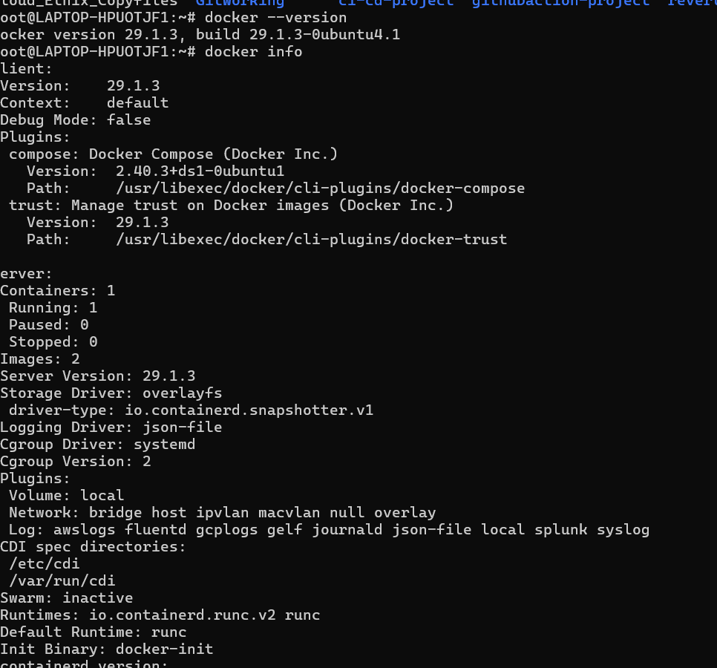

- Working with Docker images: Search for the official Ubuntu image on Docker Hub, pull it to your local system using docker pull, and list all available images on your system using docker images.
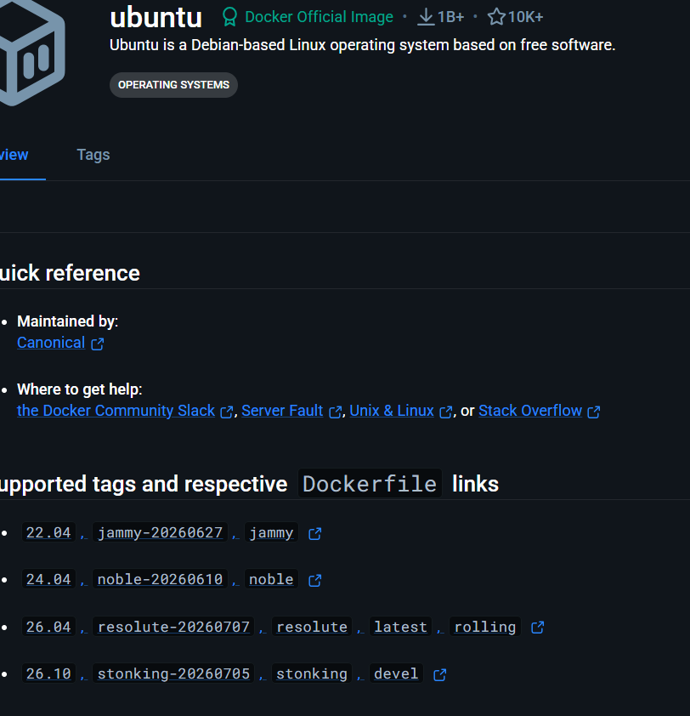
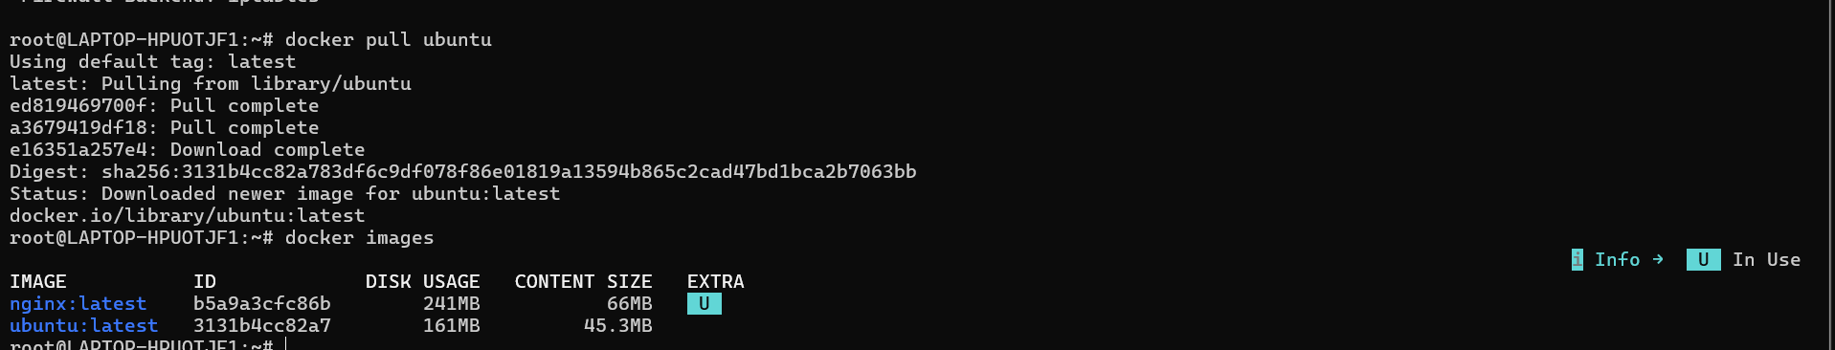
- Creating a Docker container: Run a Docker container using the Ubuntu image, and execute a command inside the container (e.g., echo "Hello, Docker!").
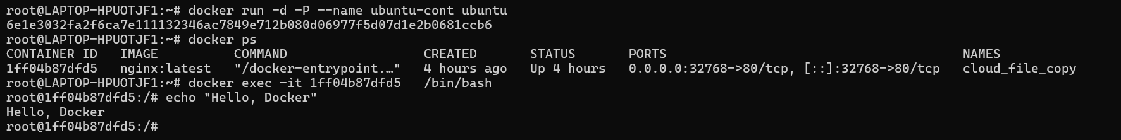
- Inspect the Ubuntu Docker container to ensure it is in the "created" state only.
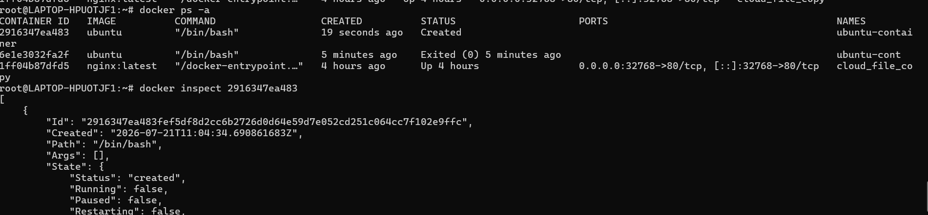
- Execute the Ubuntu Docker container and confirm that the container's state is "running."
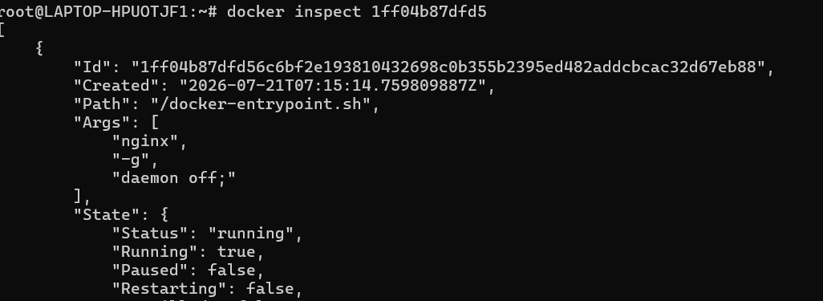
- Launch an HTTP container, verify its state, and then remove the container and image from your local system.
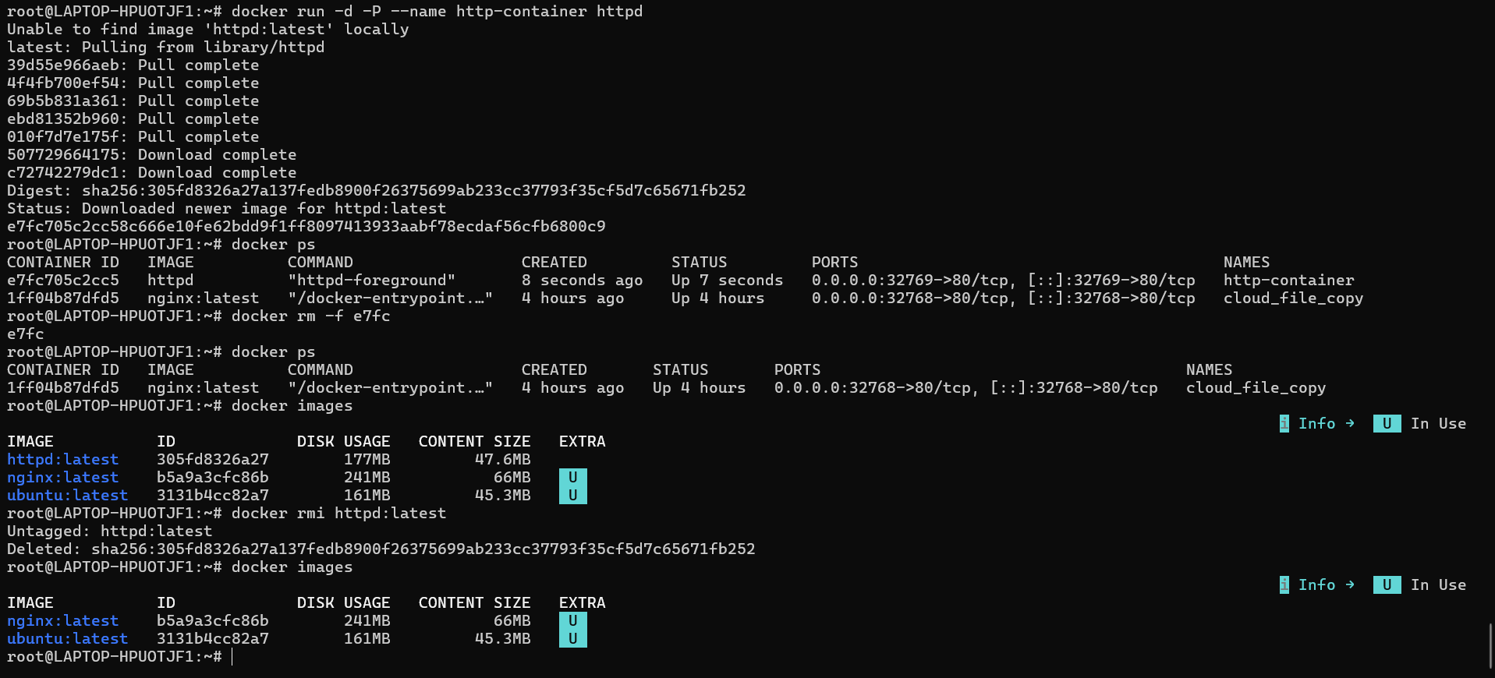
- Execute a command to display a filtered list of containers, showing only their short
container IDs.
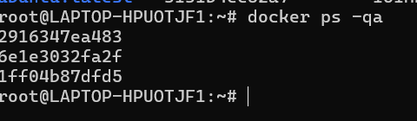
- Clone the lancachenet/ubuntu-nginx Git repository locally and build a Docker image from the provided Dockerfile. Be sure to add relevant tags when building the image.
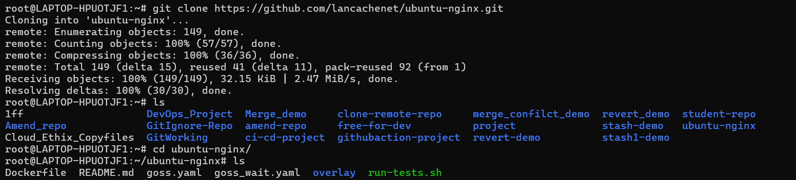
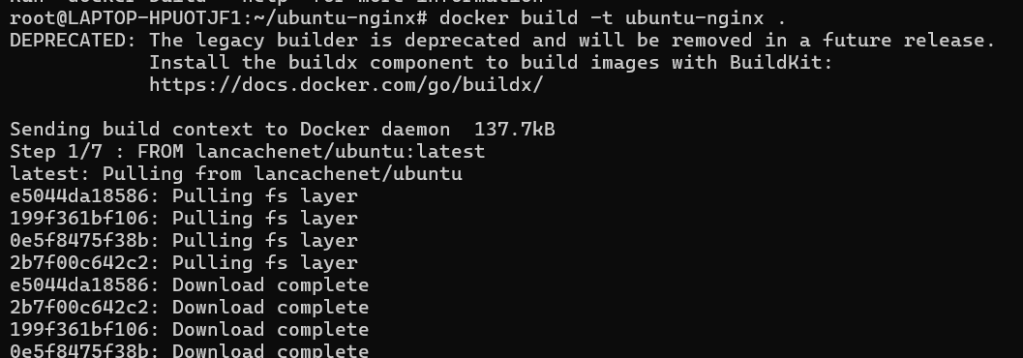
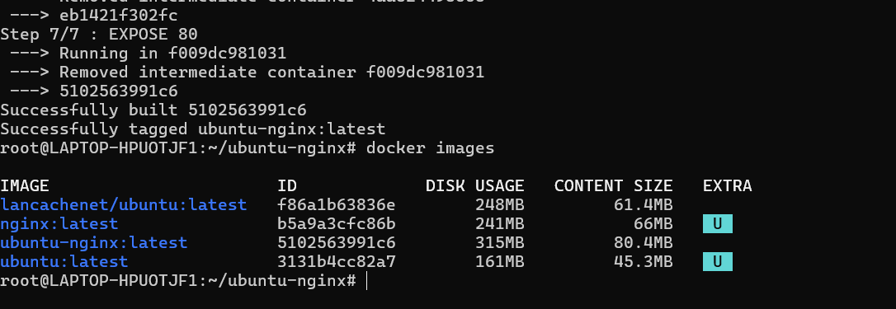

- After building the image, run a Docker container using the image and check the webpage using the curl command to ensure it's accessible.
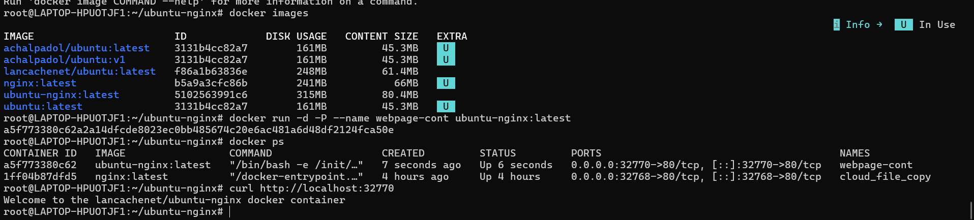

- Create a DockerHub account, set up a repository, and tag the locally created Docker image using your_repo_name/application_name:version_number.
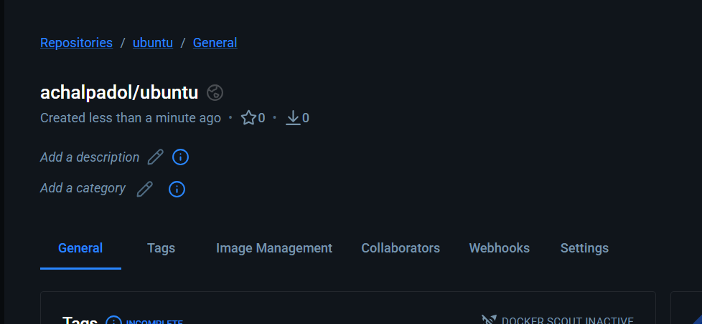
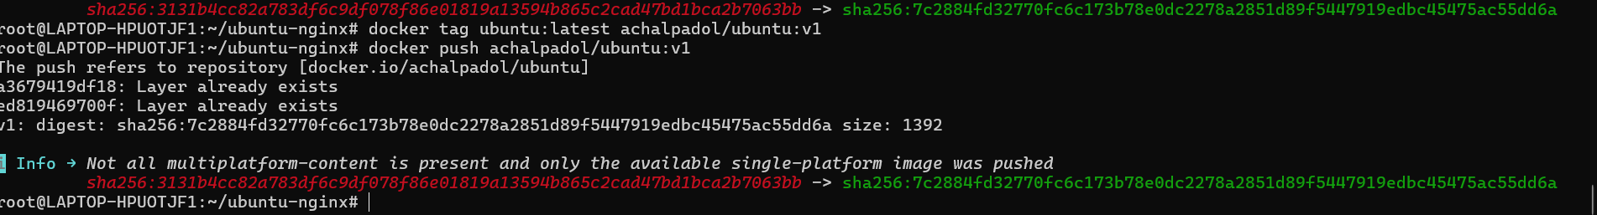
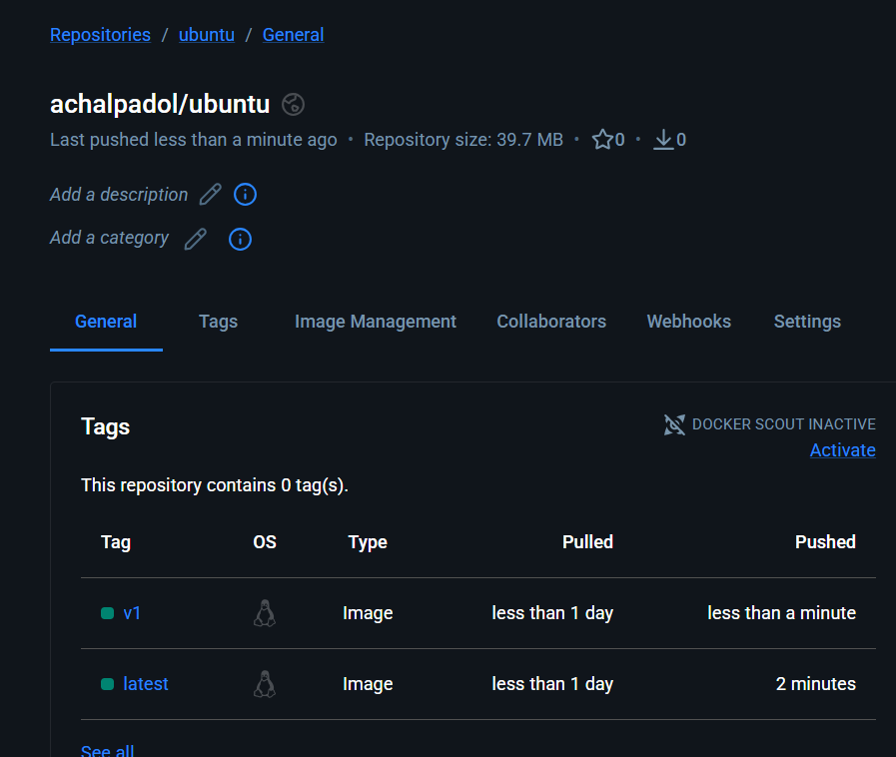
- . Launch an Ubuntu container, demonstrate that the escape sequence is functional, and reattach the container after detaching it with the escape sequence. Then, check the container's IP address.
- Launch ubuntu container and back to the terminal by using escape sequence ctrl+p and ctrl+q and then reattach then container
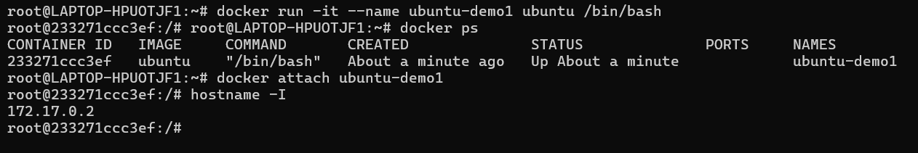
- Use a Docker command to inspect the hostname and /etc/hosts file of the httpd container.
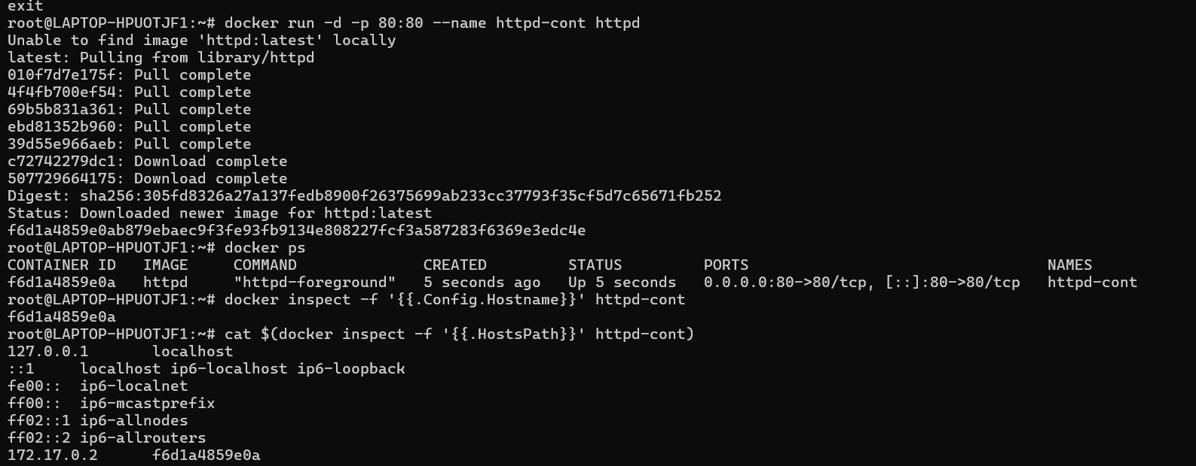
- Run a Docker command to inspect a container created with the lancachenet/ubuntu-nginx repository, and monitor the container's resource usage and stats with the TOP command.
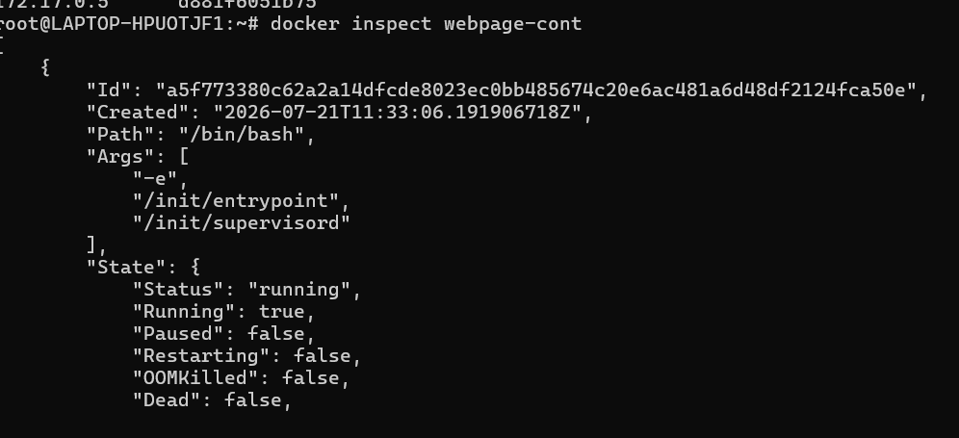
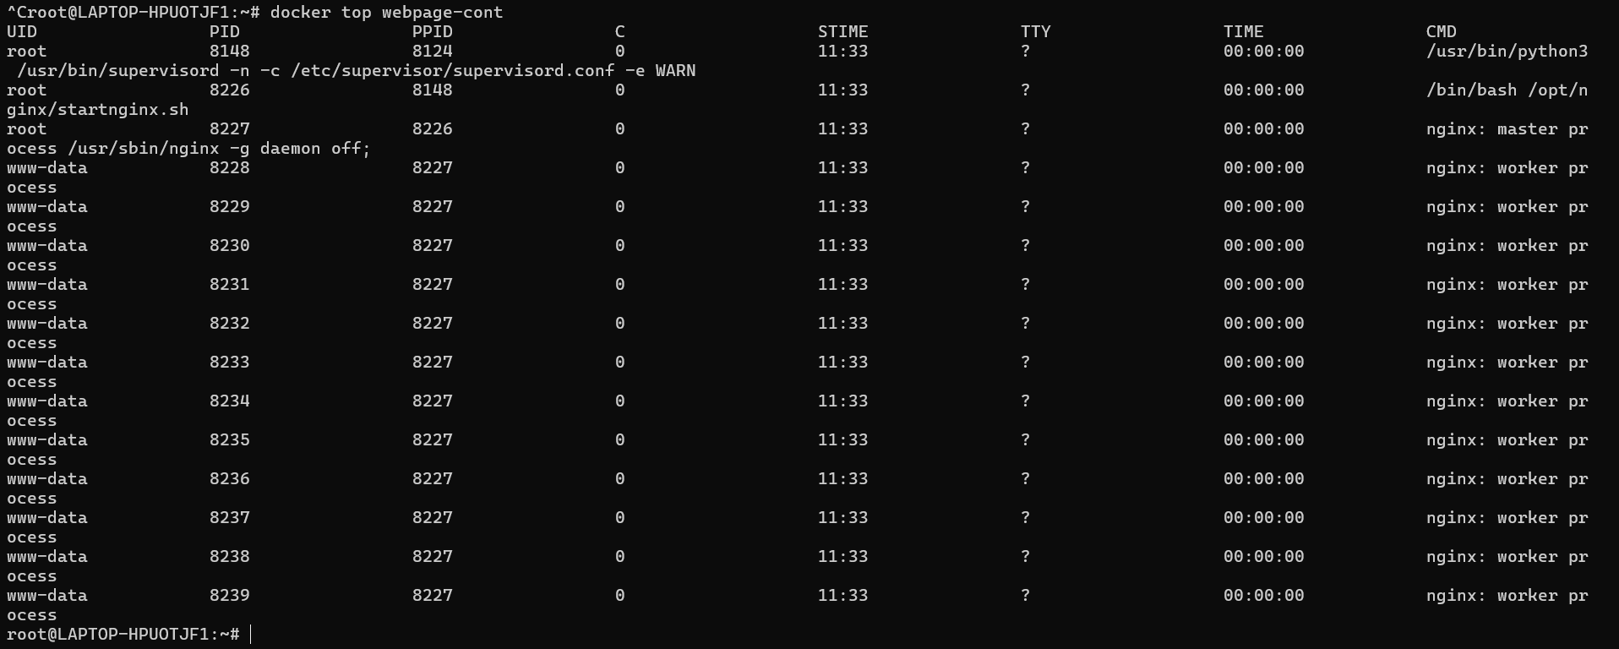
- Start a new Nginx container and review the logs for both Nginx containers.
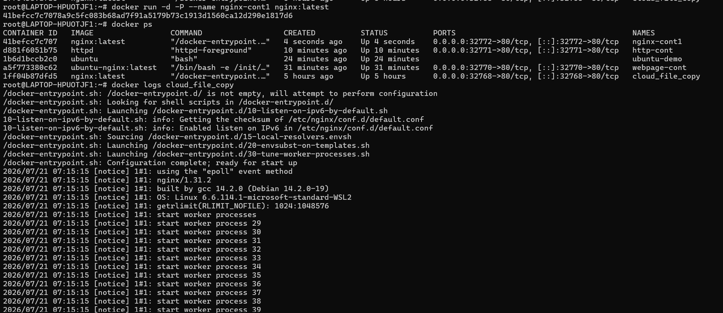
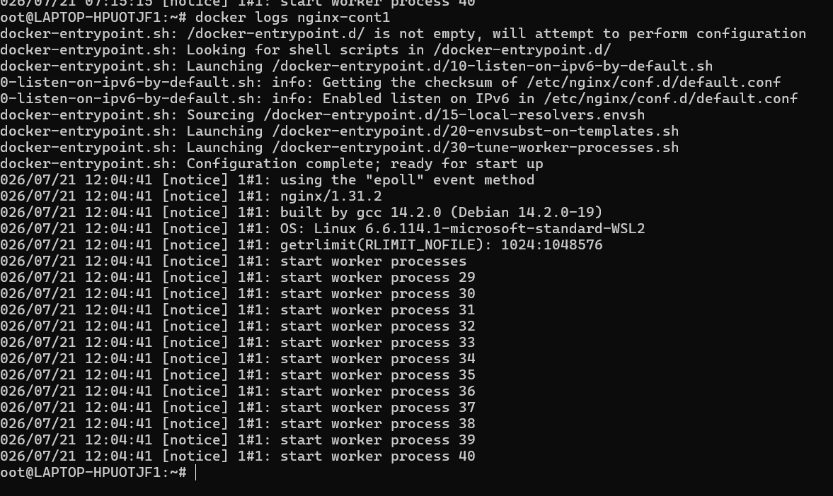
- Examine system events, filtering them by date and the last 30 minutes. Additionally, apply two filters simultaneously using name and event.
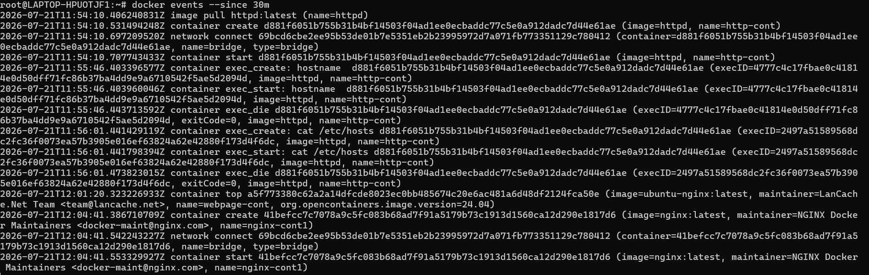
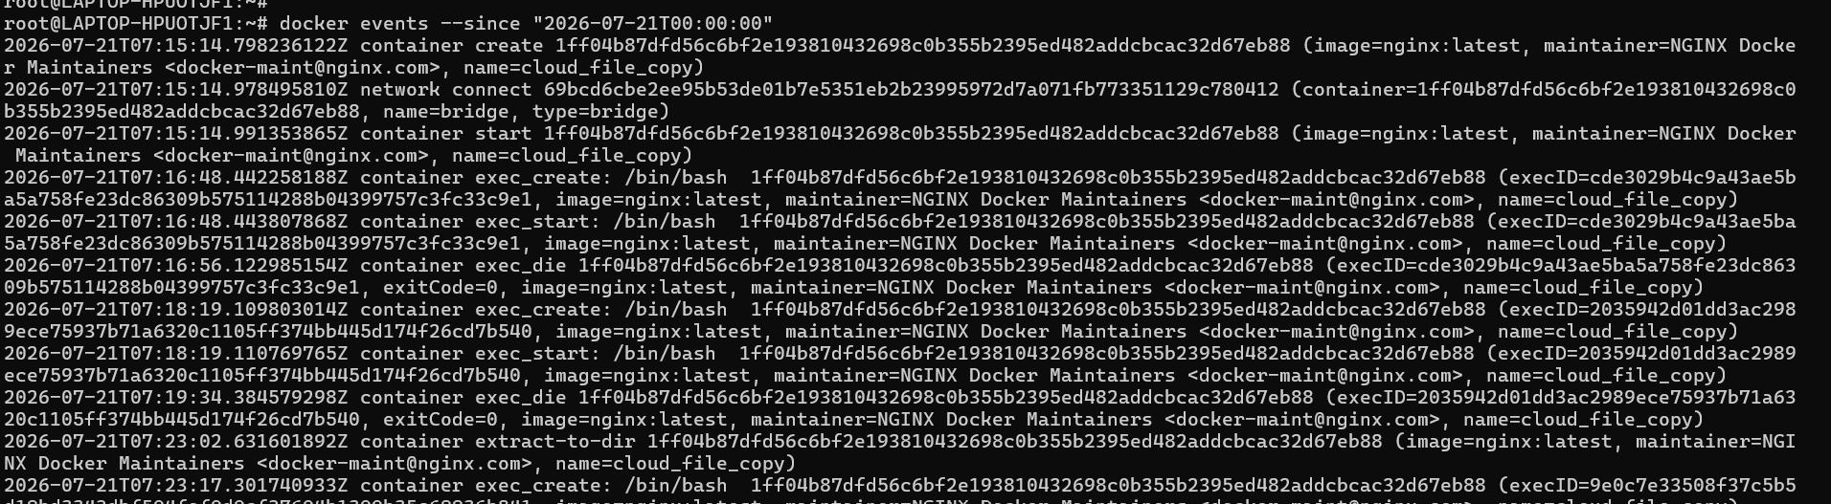
- Create a Docker container using the Ubuntu image, assign it a meaningful name, and set the hostname to "cloudethix.com." Stop or kill the container, check its exit code, and examine the container's log for more information.

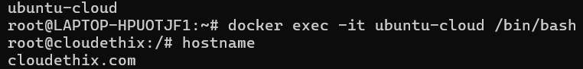

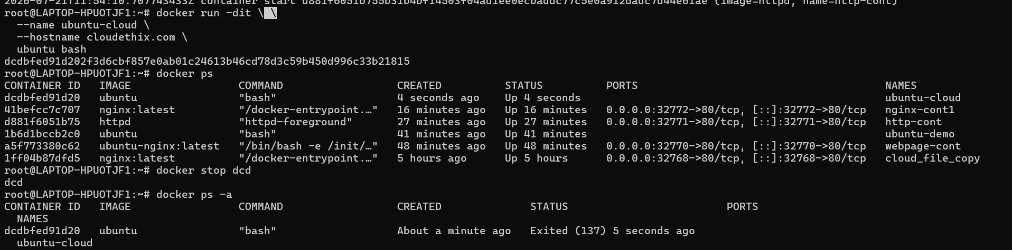
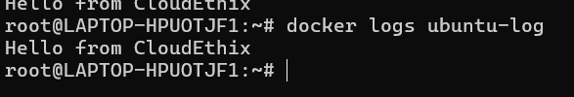
- Instantiate and start an Ubuntu container with a random name, then rename it to "Ubuntu01." Launch another container named "Ubuntu02" and check the hostname of both containers. Pause and un-pause the "Ubuntu02" container, and stop, start, and restart the "Ubuntu01" container. Inspect the stats and system events of both containers, then kill and delete them, ensuring that directories created by the containers are removed.
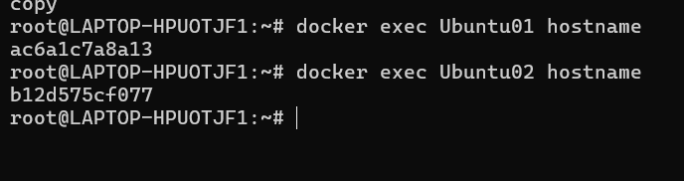
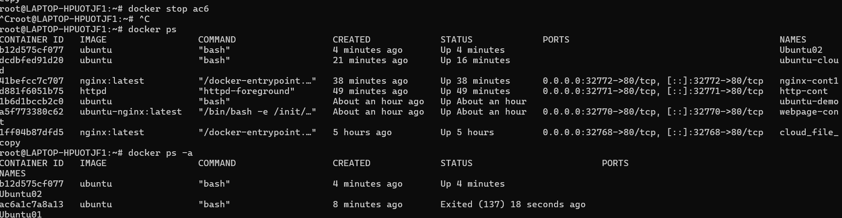
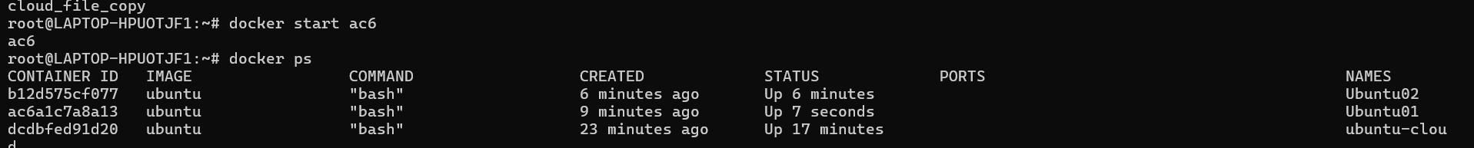
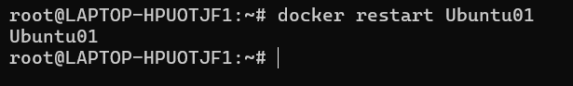
Stats of the both containers
Events of the ubuntu01
Run this cmd on the another terminal then check the events on the first terminal.
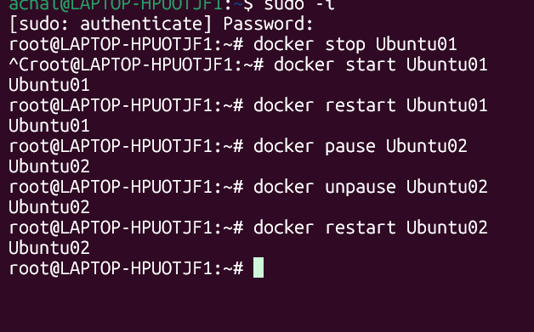
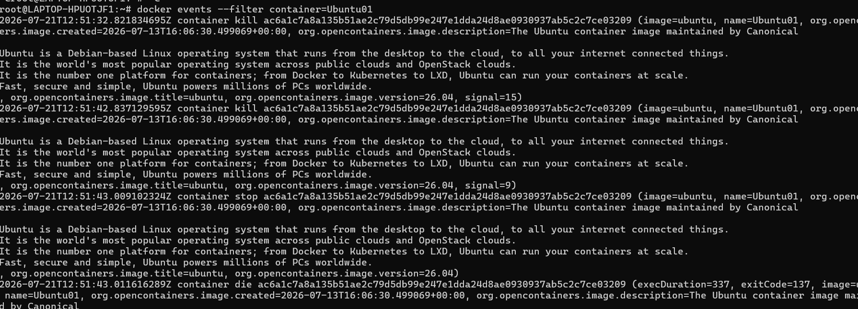
Event of the ubuntu02
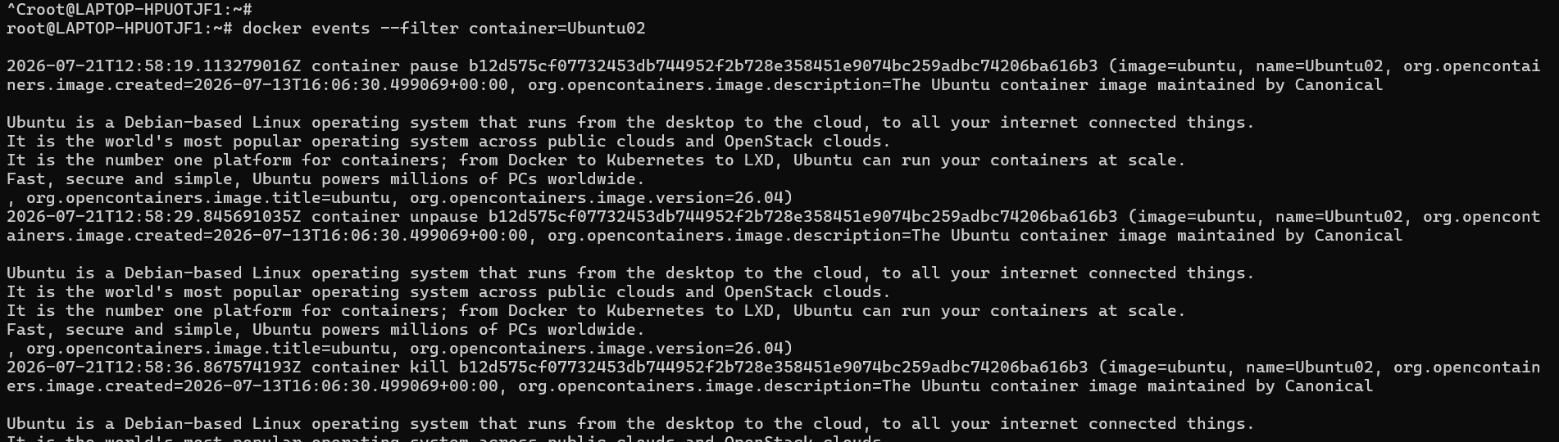

- Run four HTTPD Docker containers with distinct, meaningful names, and apply restart policies (NO, On-Failure, Always, and Unless-Stopped) to each of the four containers, respectively. Demonstrate that the restart policies function as expected.
- Four containers are created with different name

- --restart=no
No restart policy will not start container automatically
- 2. --restart=on-failure
This policy only restarts the container if the main process exits with a non-zero exit code (an error).
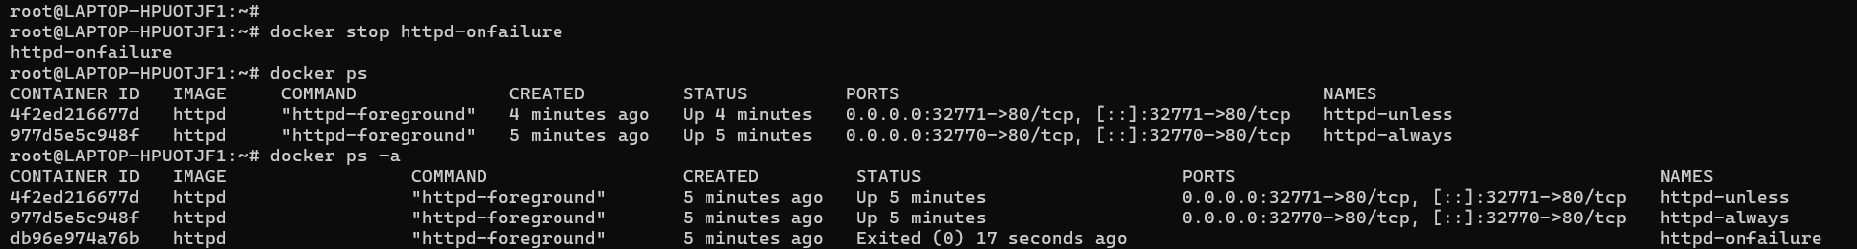
will not restart it, because docker stop sends a graceful stop signal, resulting in exit code 0.
- --restart=always
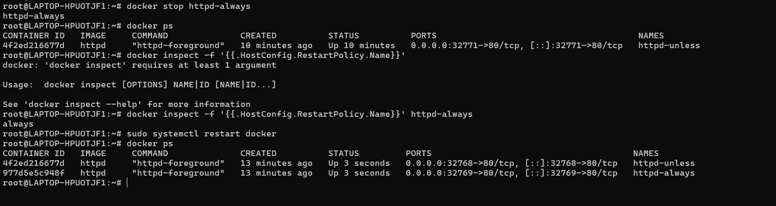
- --restart=unless-stopped
Restart the container automatically unless it was manually stopped by the user
- Launch an NGINX container with a meaningful name and expose it on the host's port 80. Create an "index.html" file containing the text "Hello there, Let's be the Team CloudEthiX," and copy the file to the container's "/usr/share/nginx/html/" location. Access the container in a browser to verify that the webpage displays correctly.
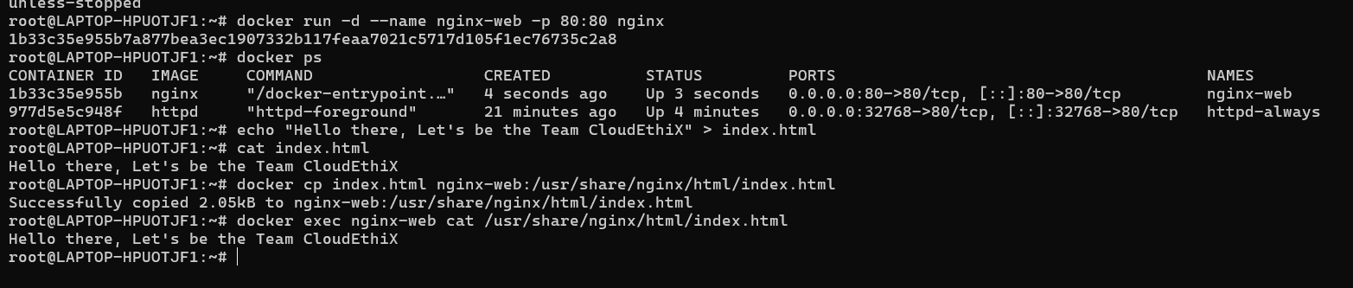
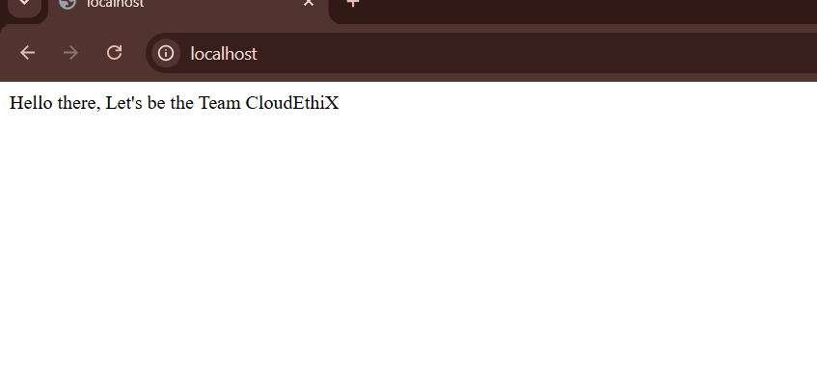
- Pull the Redis image and tag it as "yourname_redis:version 1." Create two additional tags, "yourname_redis:version 2" and "yourname_redis:version 3." Run two Docker containers from the tagged images named "redis01" and "redis02," then delete the "yourname_redis:version 2" image.
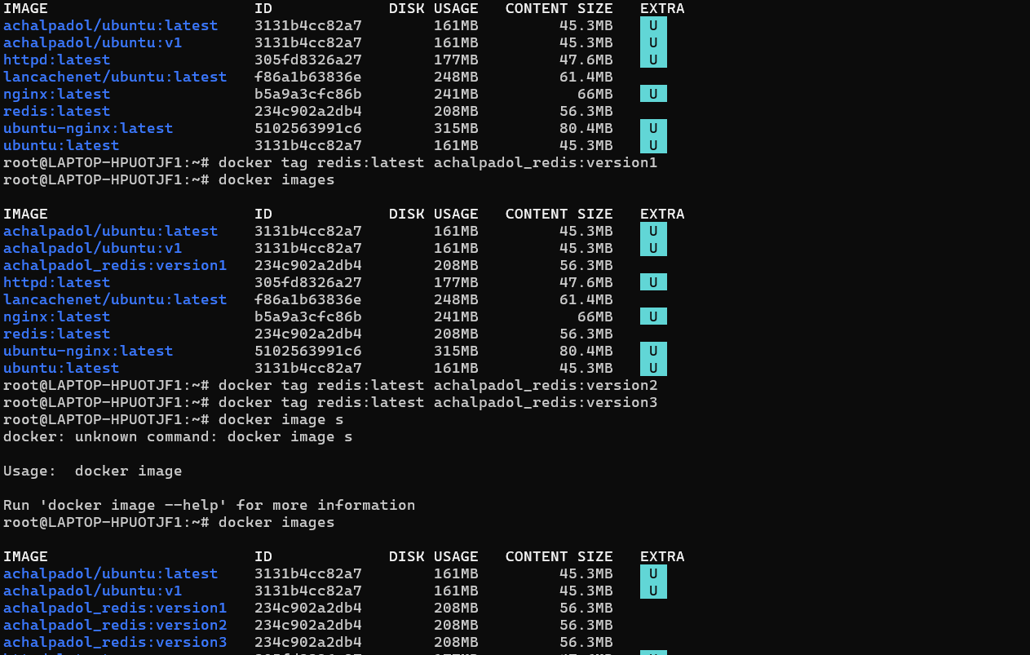
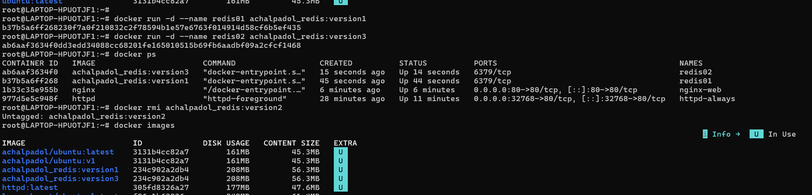
- Clone the GitHub - docker-library/httpd: Docker Official Image packaging for Apache HTTP Server Git repository locally and build the httpd Docker image from the Dockerfile at the "httpd/2.4/Dockerfile" path. Run and expose a Docker container from this image with a meaningful name on port 8181, then access the webpage in a browser. Afterward, tag the image as V1.
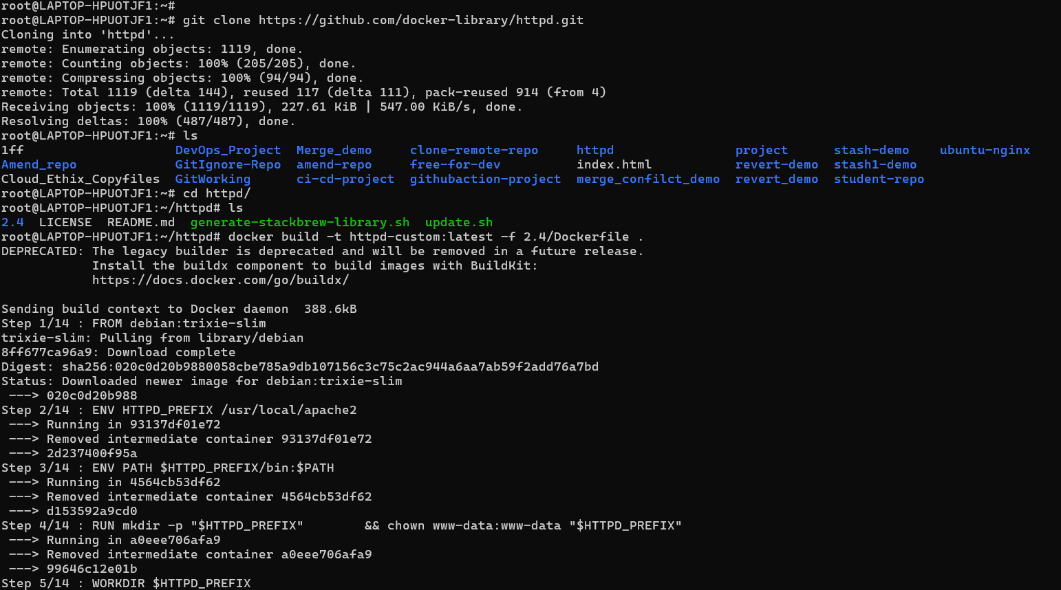
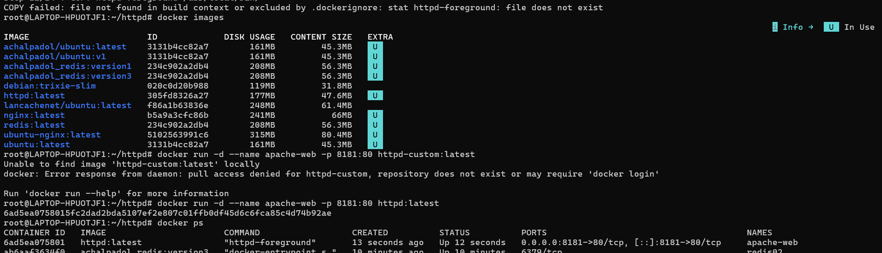
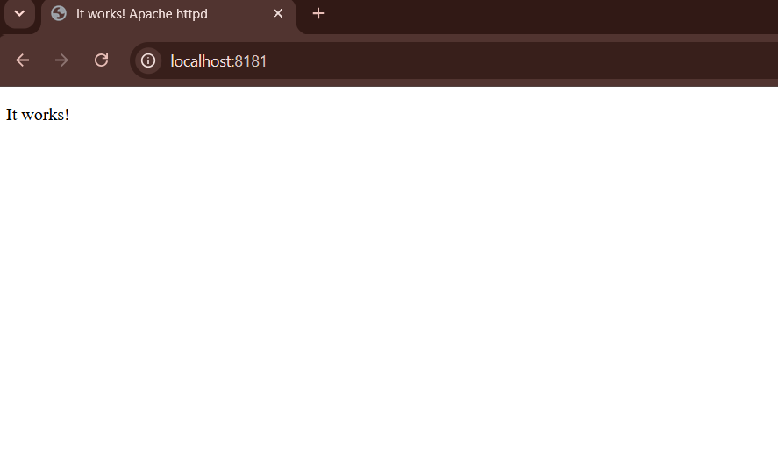
- tag the image as V1.

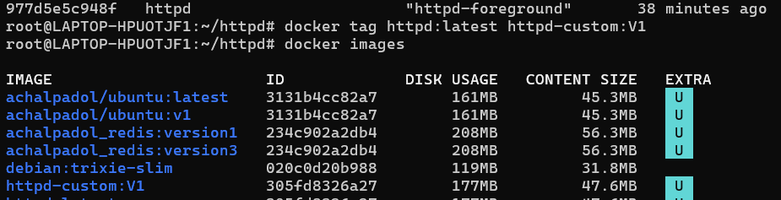
- Create a Docker Hub account and generate a security token. Establish a Docker Hub repository named "yourname_cloudethix_httpd." Log in to Docker Hub and push the previously tagged httpd image to your repository.
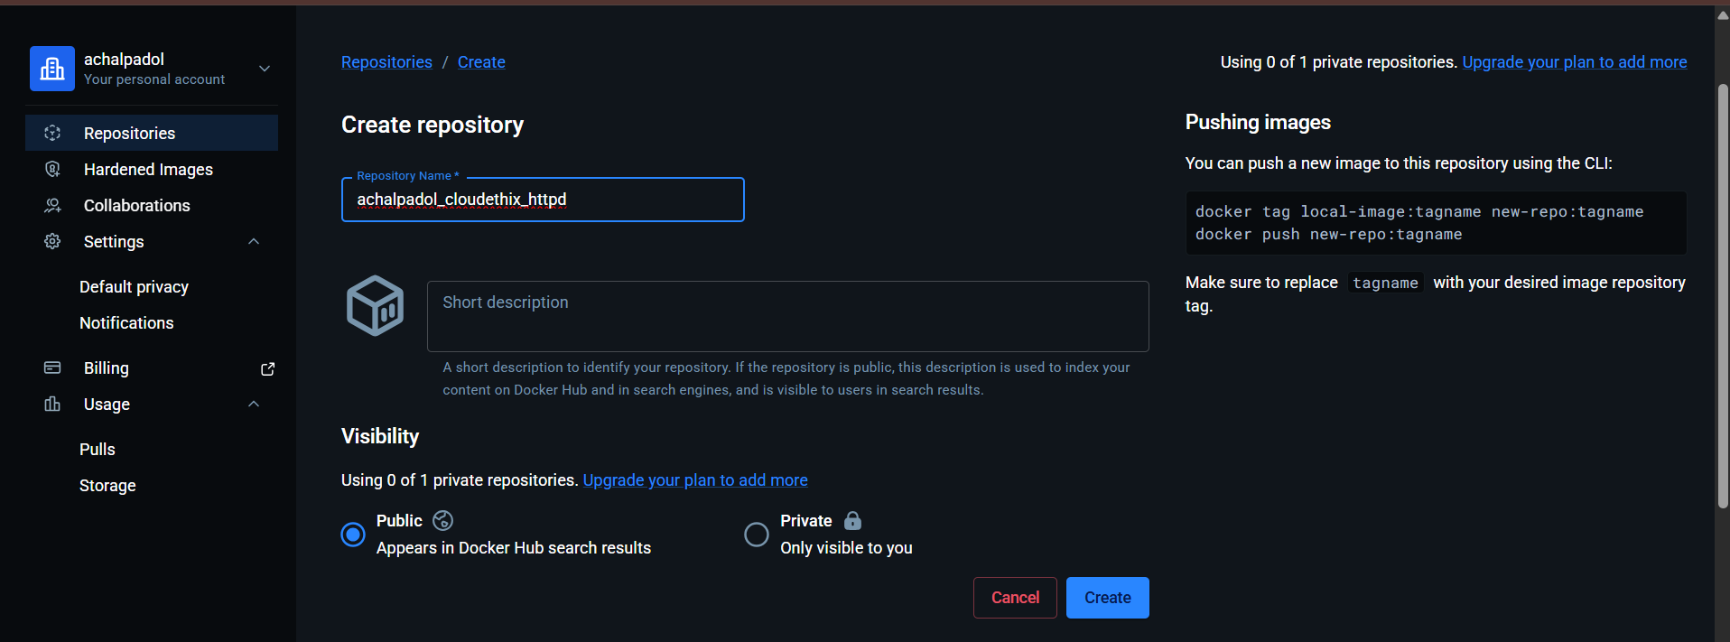
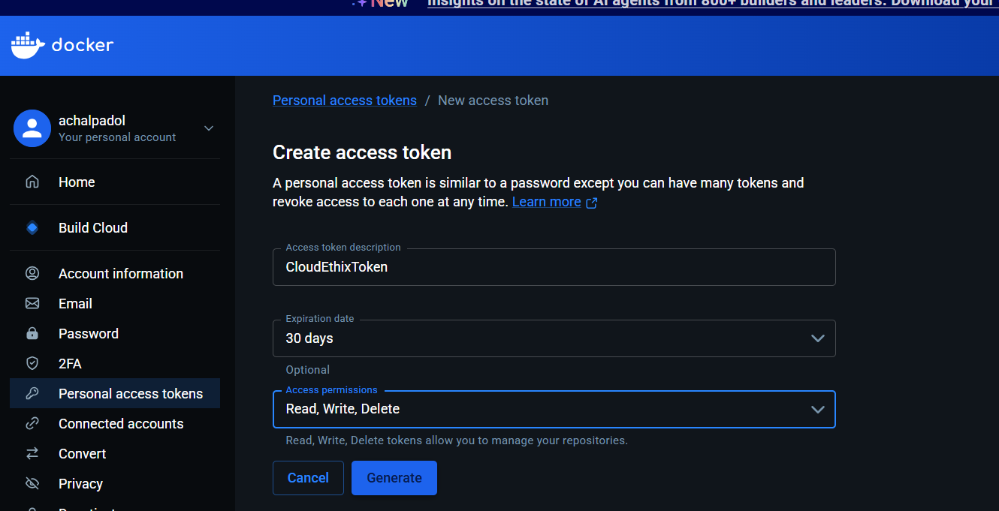
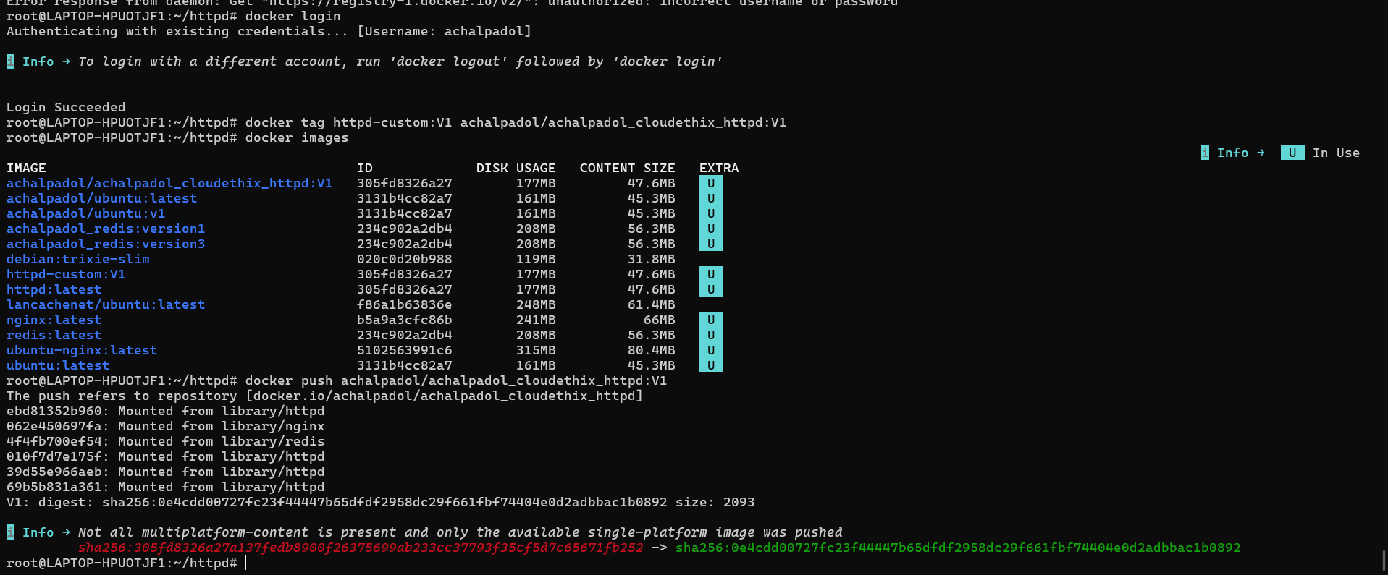
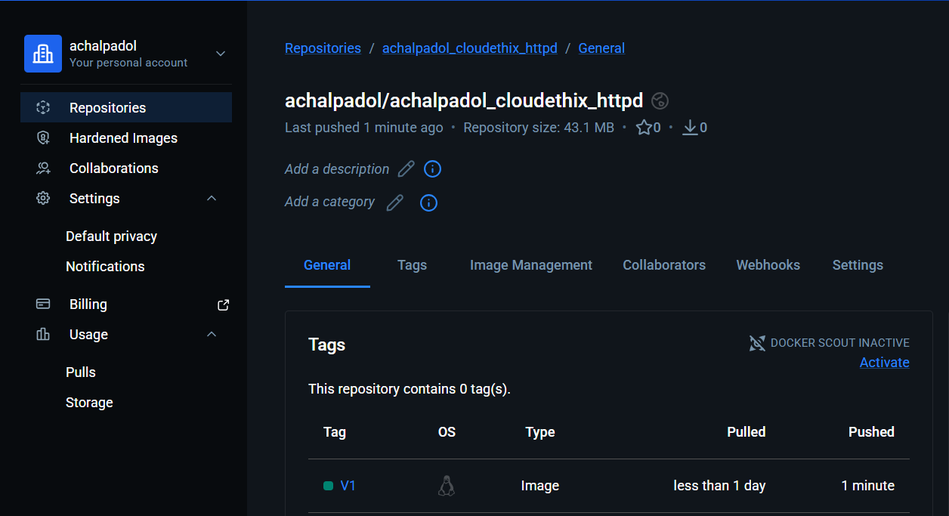
- Push the Redis images tagged as version 1 and 3 to your Docker Hub repository, named "yourname_cloudethix_redis."
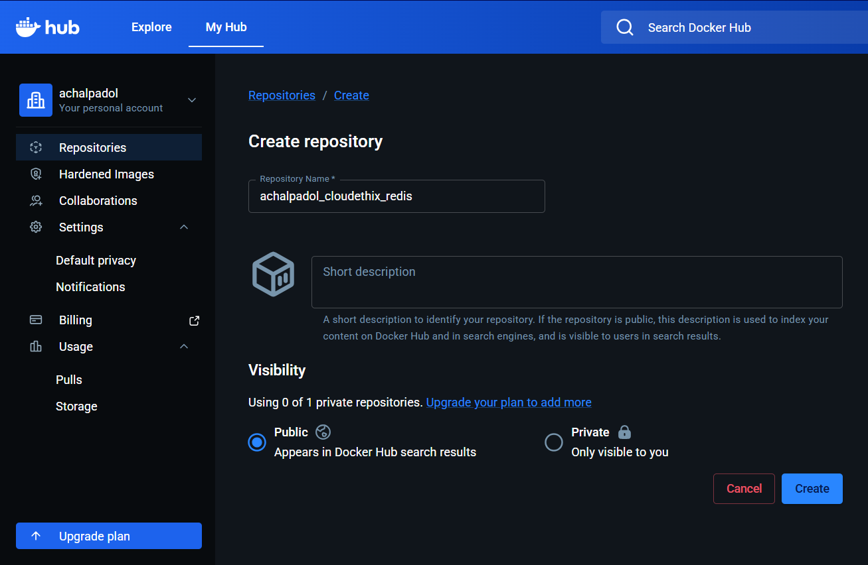
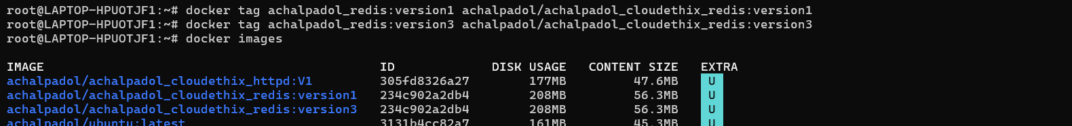
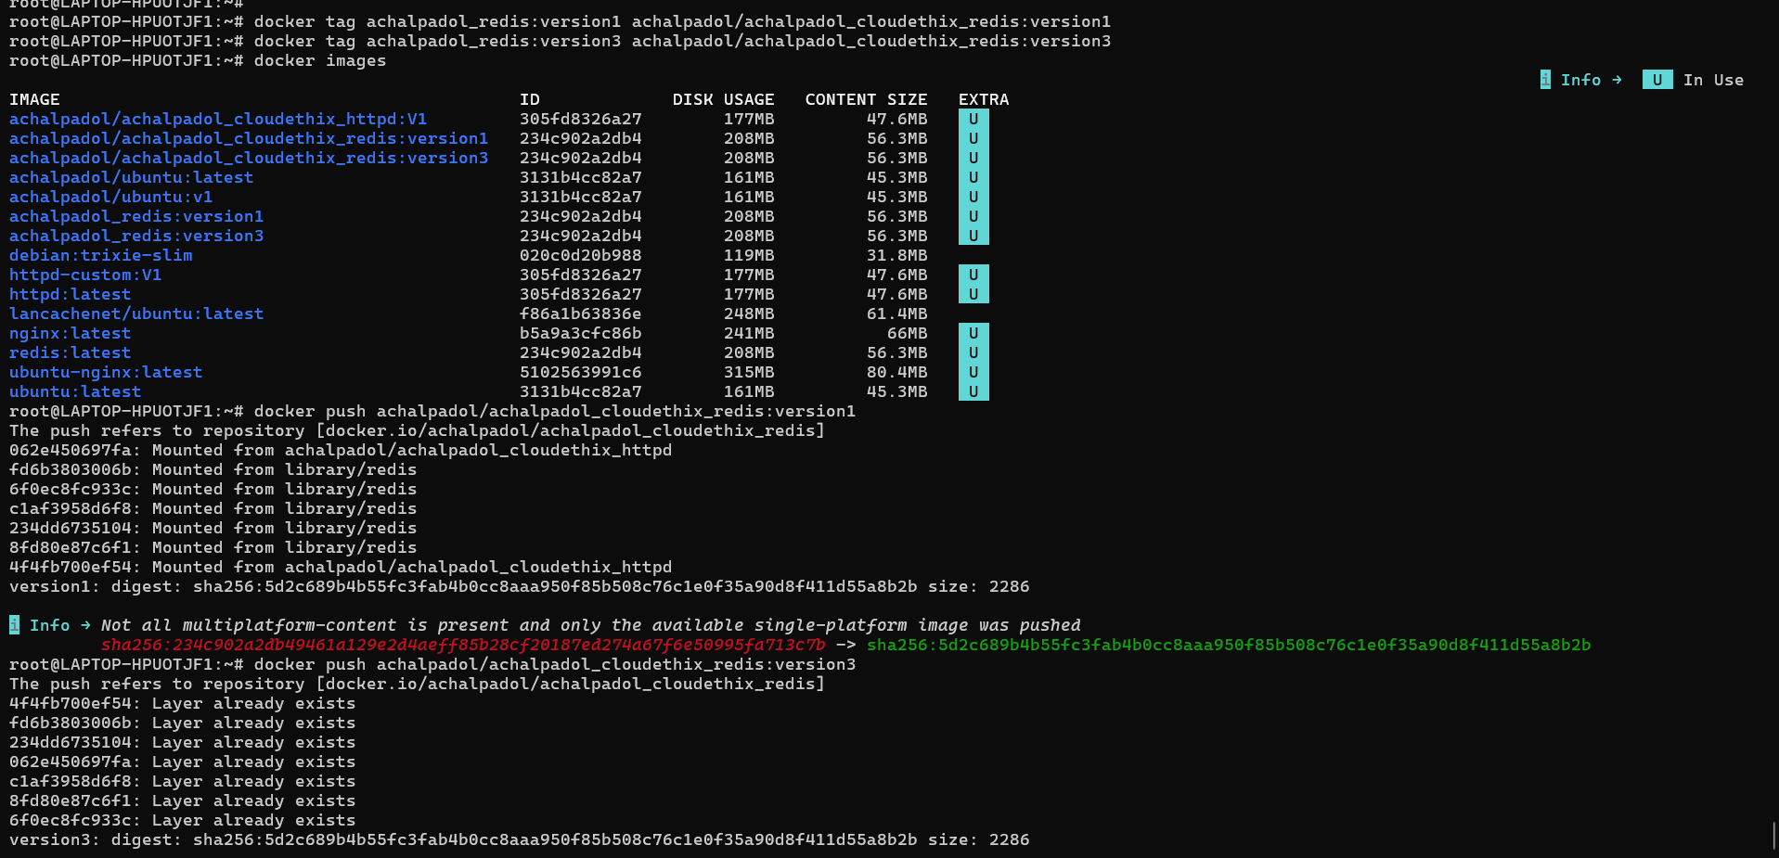
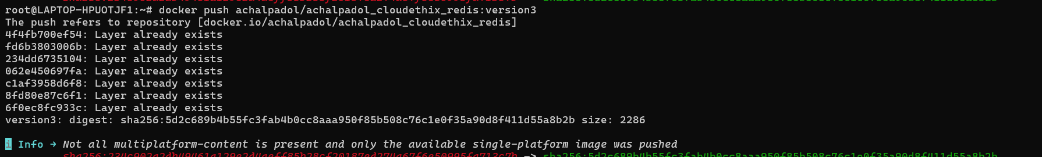
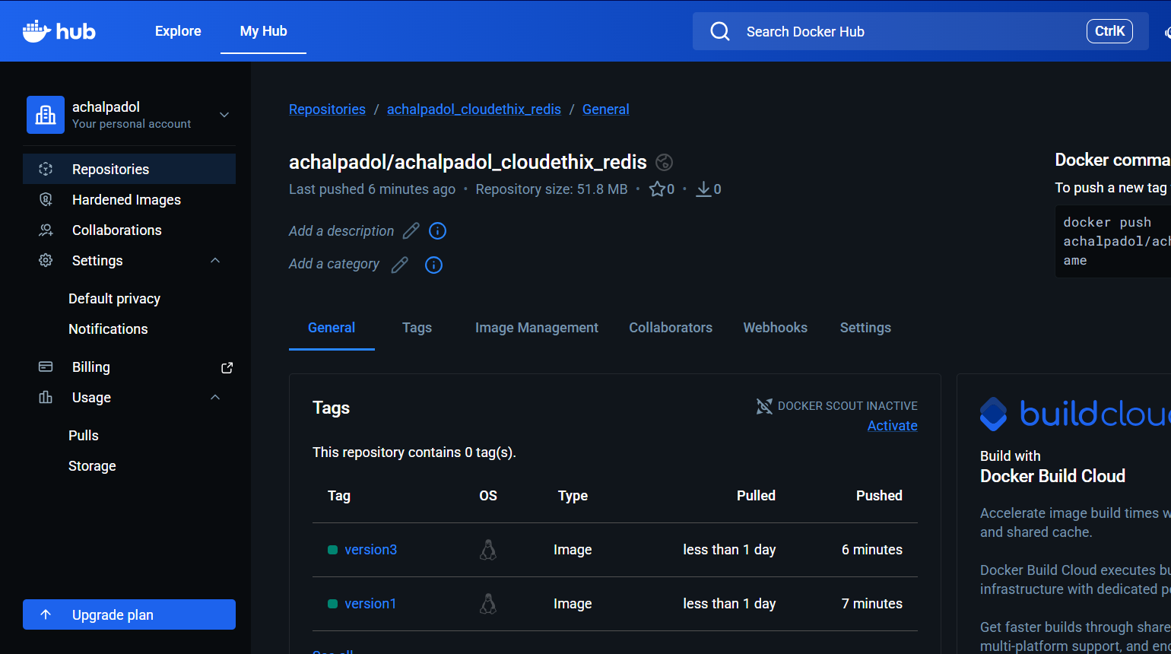
- Create a remote Git repository and add the Dockerfile and index.html files. Clone the repository locally and create a release branch. Build the Docker image from the release branch with a meaningful tag, then run a container from the image and expose it on host port 8383. Check the webpage in a browser, and upon success, push the image to your Docker Hub repository named "yourname_cloudethix_nginx." Finally, push the release branch to the remote Git repository and merge it by creating a pull request.
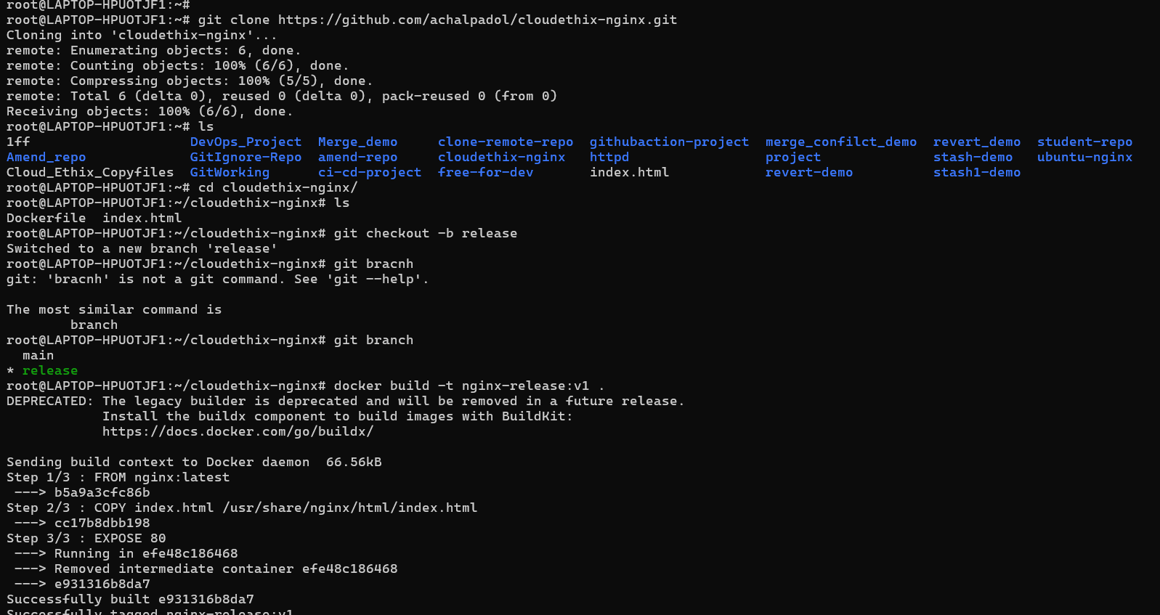
run a container from the image and expose it on host port 8383.
. Check the webpage in a browser
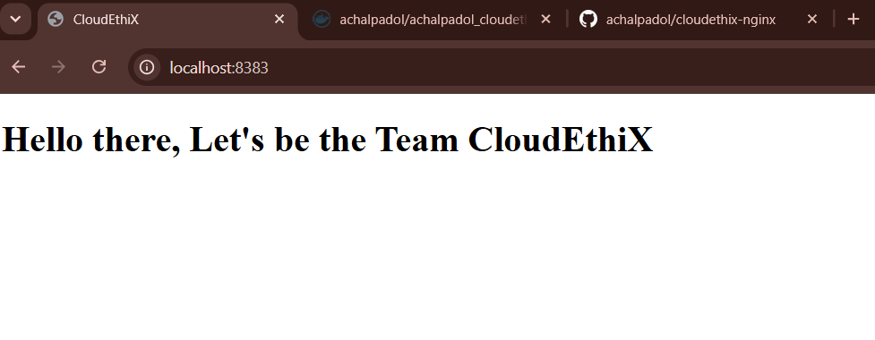
push the image to your Docker Hub repository named
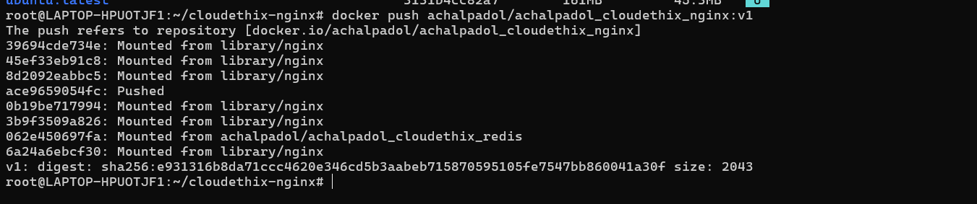
Finally, push the release branch to the remote Git repository and merge it by creating a pull request.

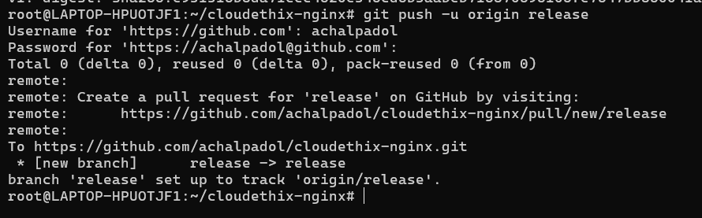
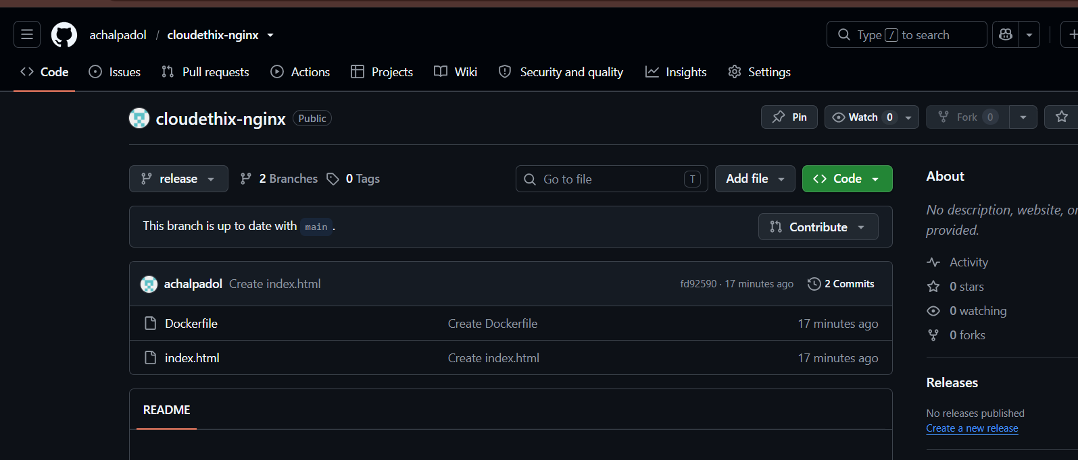
- Save all local Redis images as a .tar file in the master branch of your local repository. Delete all Redis images from your local system and push the master branch to the remote repository. Load the Redis images from the tar file to your local system, and verify that all images have been loaded correctly.
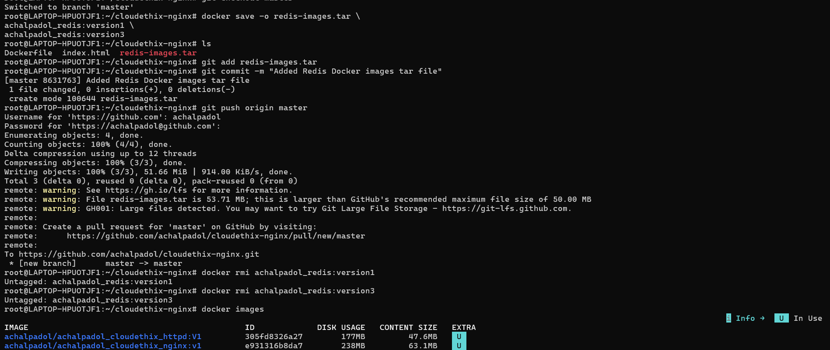
. Load the Redis images from the tar file to your local system, and verify that all images have been loaded correctly.
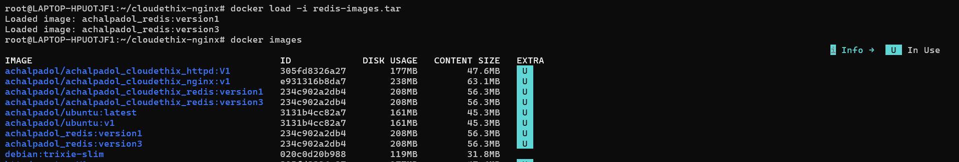
- Pull the Busy-box image to your local system, tag it, and push it to the Docker Hub repository "yourname_cloudethix_busybox." Export the Docker image from the NGINX container, create a .tar file, and import the tar file to create a Docker image with a meaningful name. After importing the image, tag it and push it to the "yourname_cloudethix_busybox" Docker Hub repository.

- Pull the busy-box image to your local system
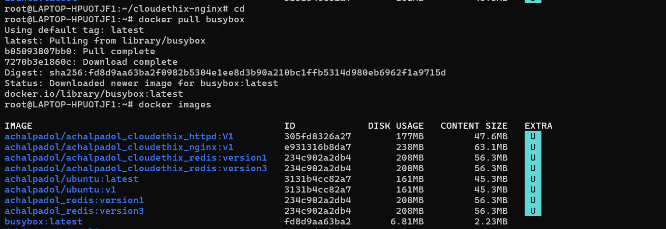
-tag it and push to the Docker Hub
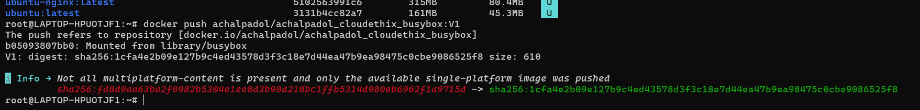
- Export the Docker image from the NGINX container, create a .tar file
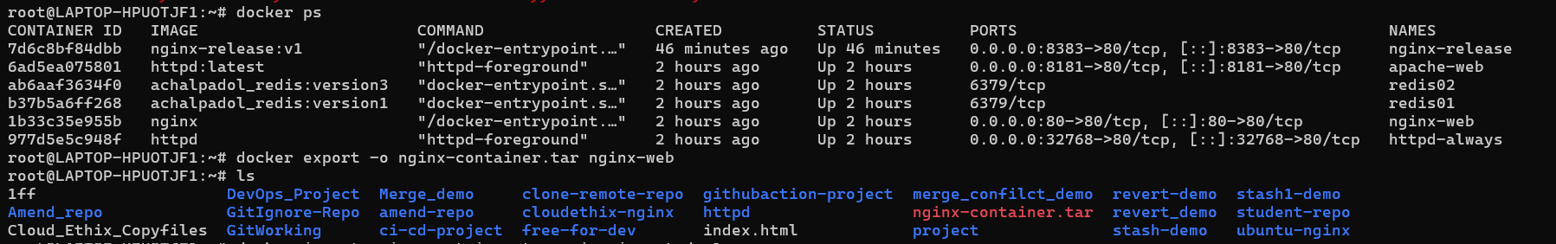
- import the tar file to create a Docker image with a meaningful name.
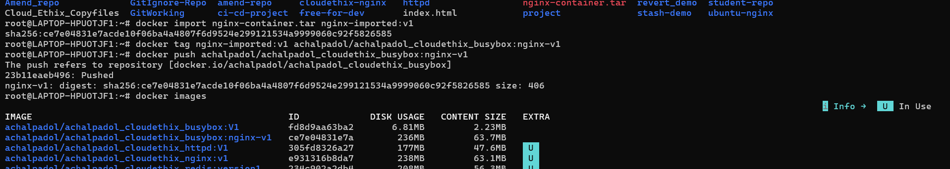
- push it to the "yourname_cloudethix_busybox" Docker Hub repository.
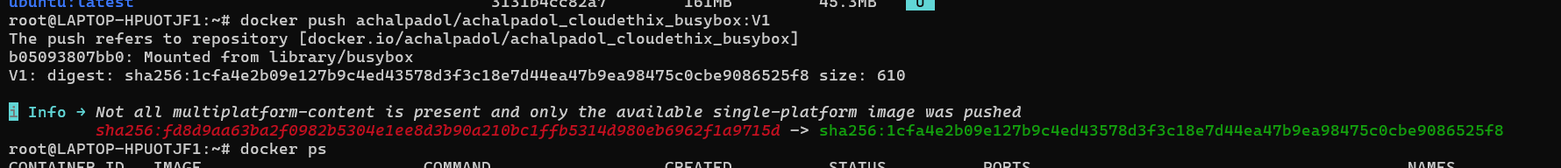
- Dockerfile creation: Create a simple Dockerfile to build a custom image with the following specifications:
-Base image: Ubuntu
-Install packages: curl, vim, and git
-Set an environment variable: MY_NAME=Your_Name
-Build the custom image using docker build and list all available images using docker images.

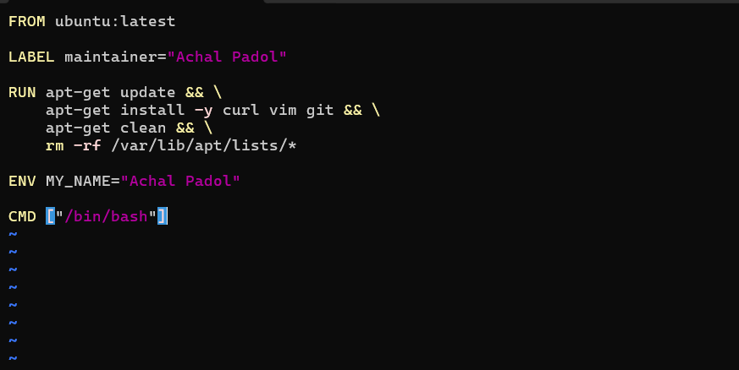
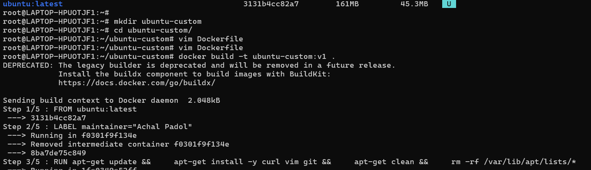
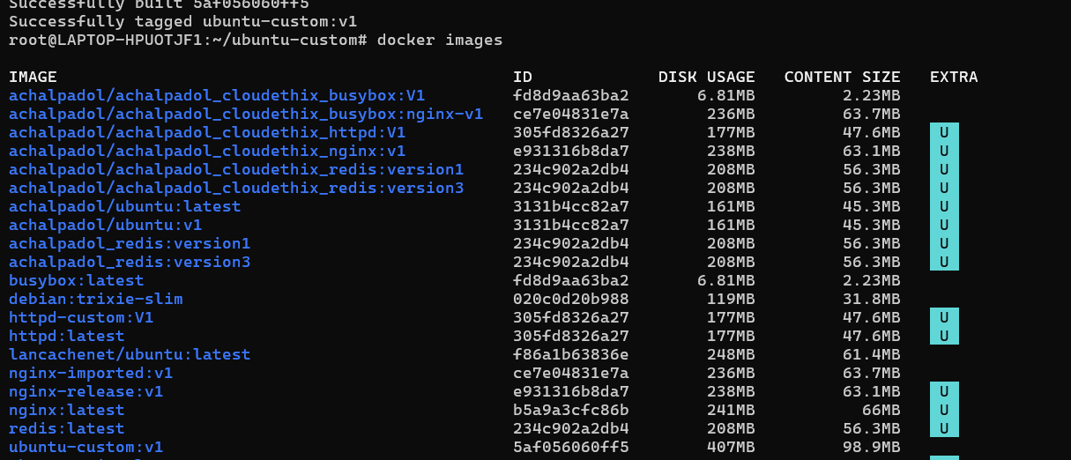
- Docker networking: Create two Docker containers with different names, and add them to the same custom network. Verify that the containers can communicate with each other using their names as hostnames.

-Create Docker Network
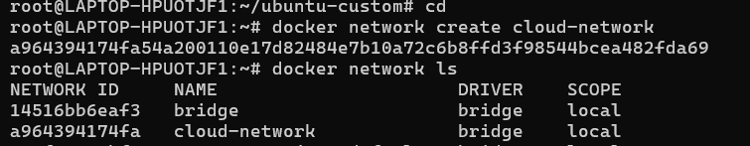
-Create two Docker containers with different names, and add them to the same custom network.
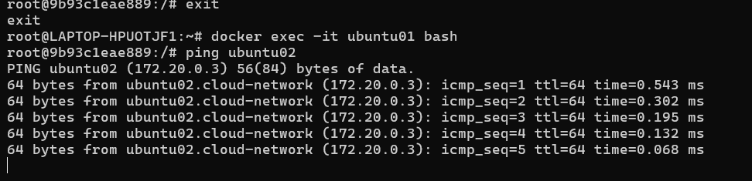
- Data persistence with volumes: Run a Docker container with an attached volume, create a file inside the volume, and verify that the file persists after the container is stopped and removed.
-Create a container with attach volume
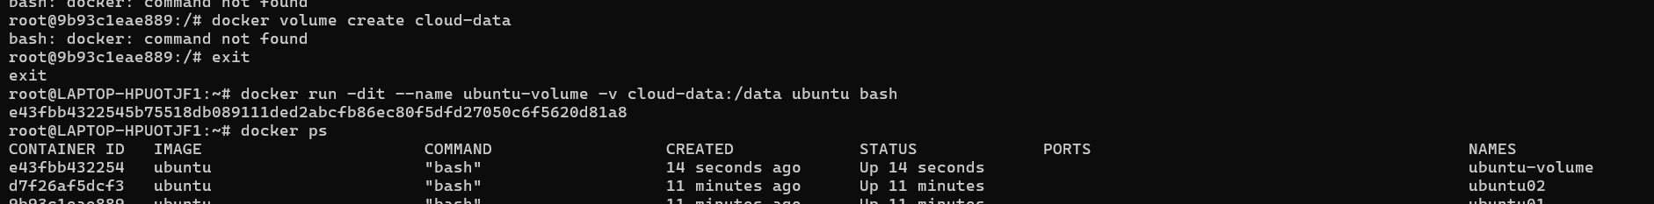
-Create a file inside the volume
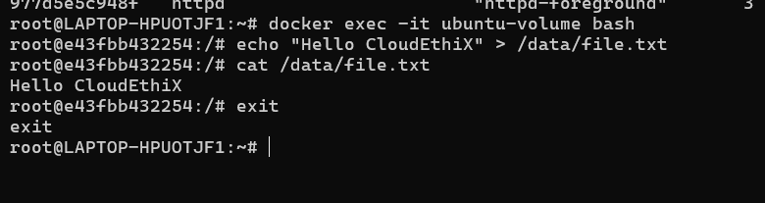
- verify that the file persists after the container is stopped and removed.
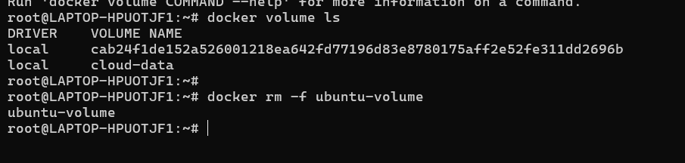
-create new container and attach volume to the new container and verify the data
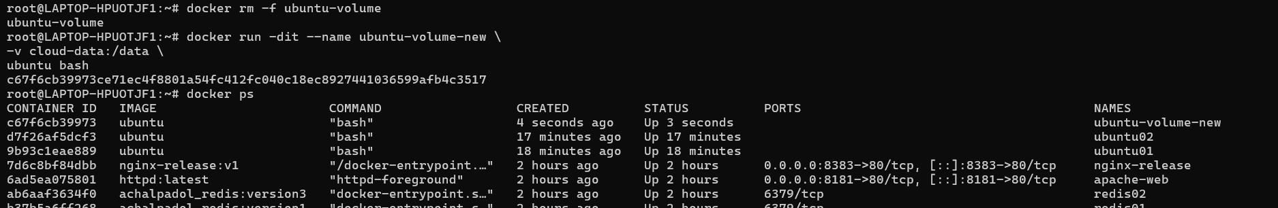
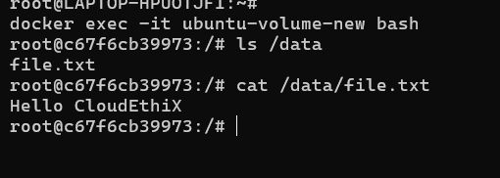
- Docker Compose: Create a docker-compose.yml file to run a multi-container application consisting of a web server (e.g., Nginx) and a database server (e.g., MySQL). Ensure that both containers are connected to the same network.
-create docker compose file to create multi-container
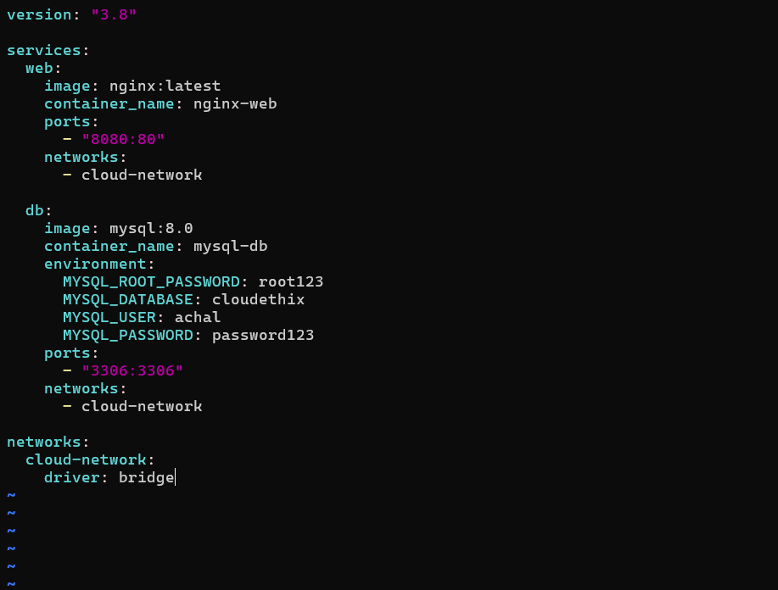
-run both the container
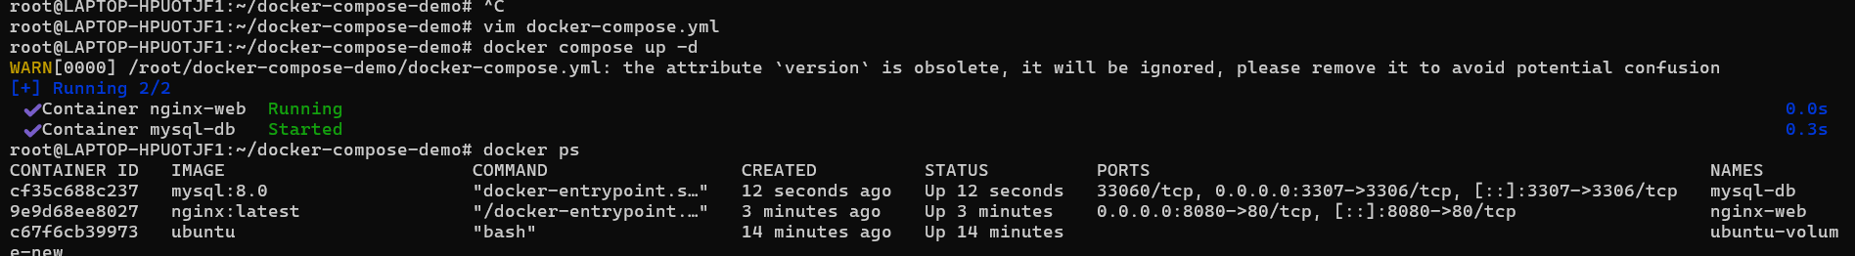
- Ensure that both containers are connected to the same network.
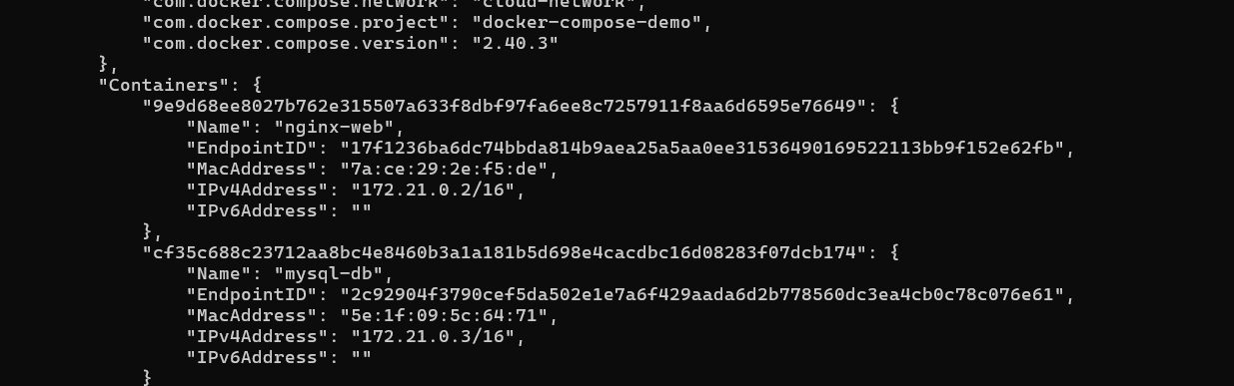
- Container logging: Run a Docker container that generates log output, and practice using docker logs to view and analyze the logs.
View logs
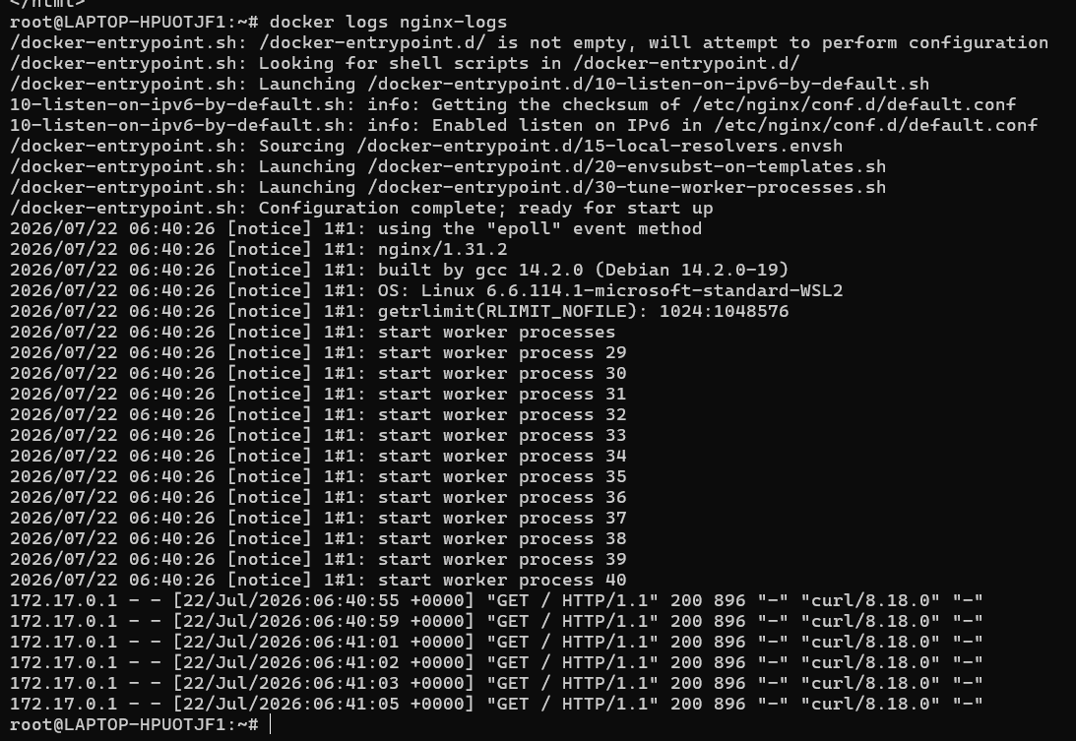
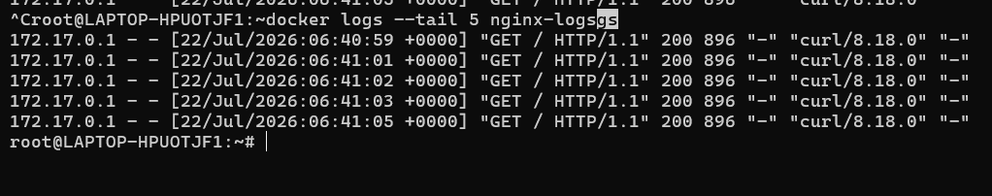
- Container resource monitoring: Run a Docker container that consumes system resources (e.g., CPU or memory) and practice using docker stats and docker top to monitor the container's resource usage.
-docker stats
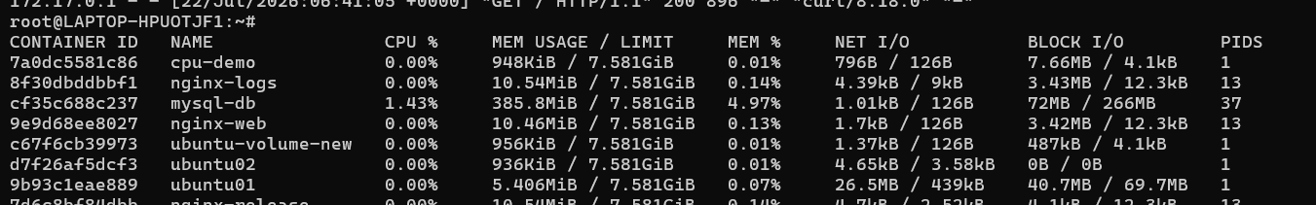
-docker stat cpu-demo
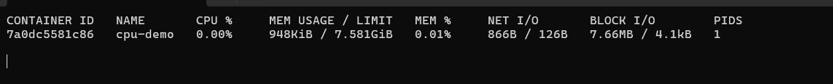
-docker top cup-demo
- Updating a containerized application: Update the source code of a simple containerized application, rebuild the Docker image, and deploy the updated version while minimizing downtime.
-index.html file
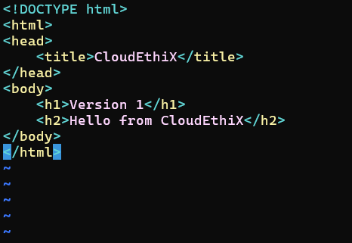
-build docker image form the created Dockerfile
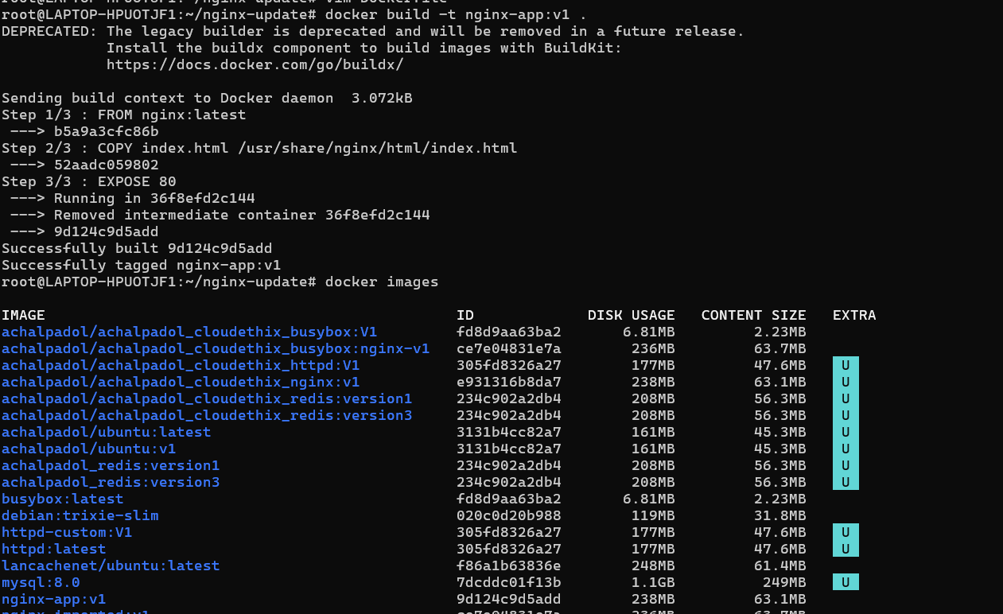
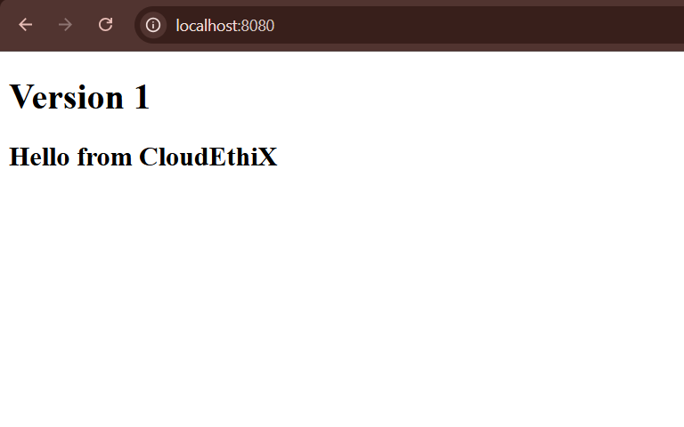
-Update the source code file
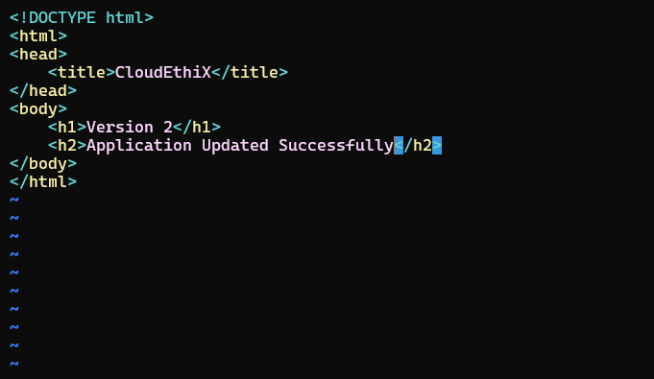
-access the application through the browser
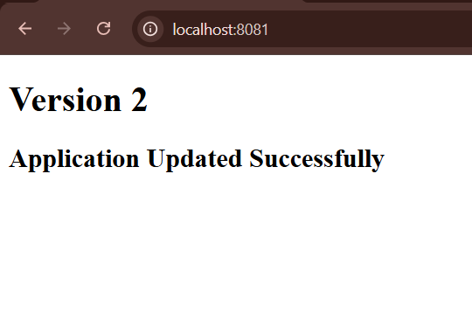
- Bridge network: Create two Docker containers using different images, such as NGINX and MySQL. Connect them using a user-defined bridge network and ensure they can communicate with each other.
-create two docker containers using different images such as NGINX and MySQL
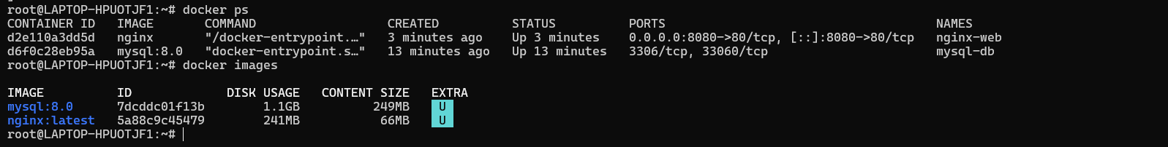
- ensure they can communicate with each other.
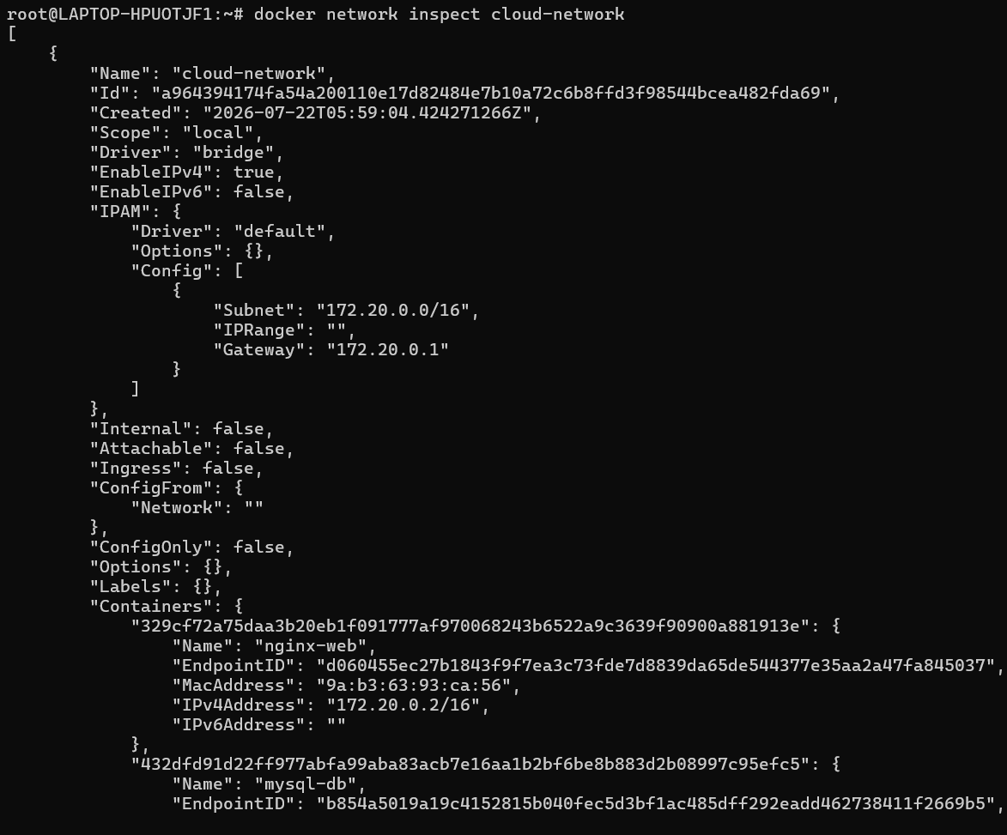
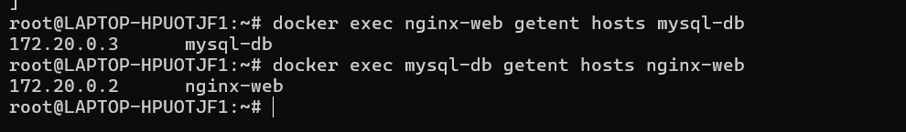
- Port mapping: Run a containerized web server (e.g., NGINX or Apache) and map its default port (80 or 443) to a custom port on the host machine. Verify that the web server is accessible through the custom port on the host.

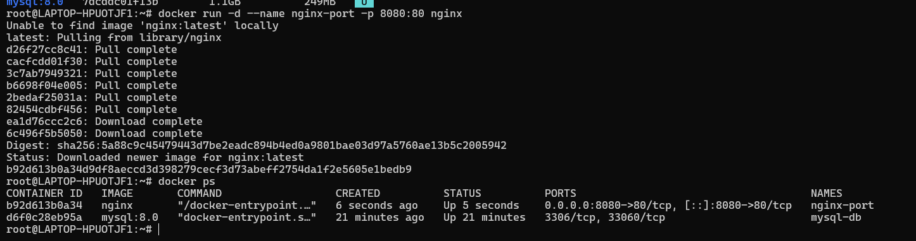
- Verify that the web server is accessible through the custom port on the host.

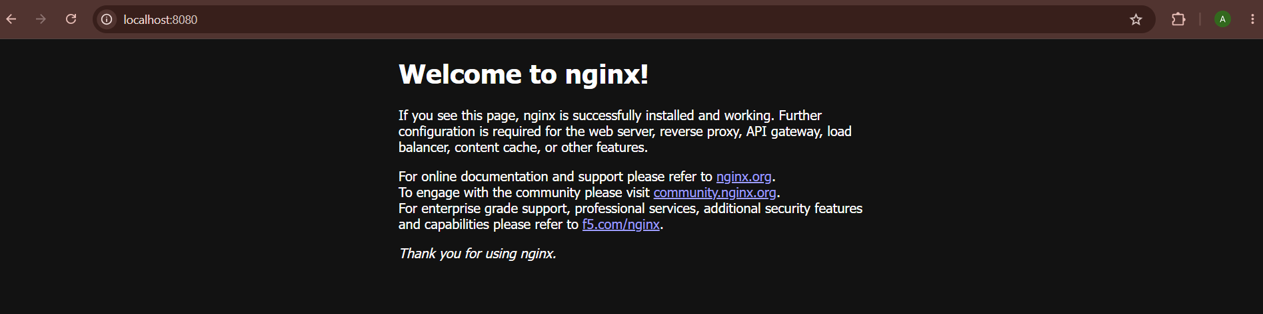
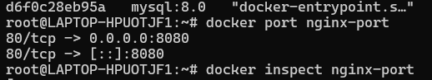
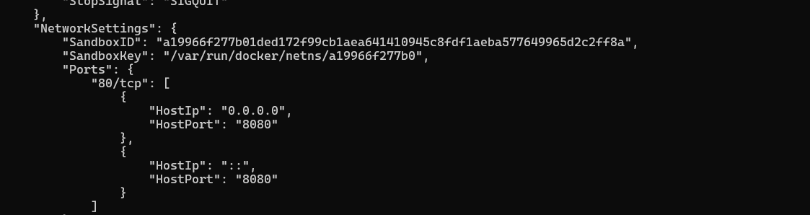
- Host networking: Run a container with the host networking mode and compare its network configuration with that of the host machine. Explain the advantages and disadvantages of using host networking for containers.
- Run a container with the host networking mode and compare its network configuration
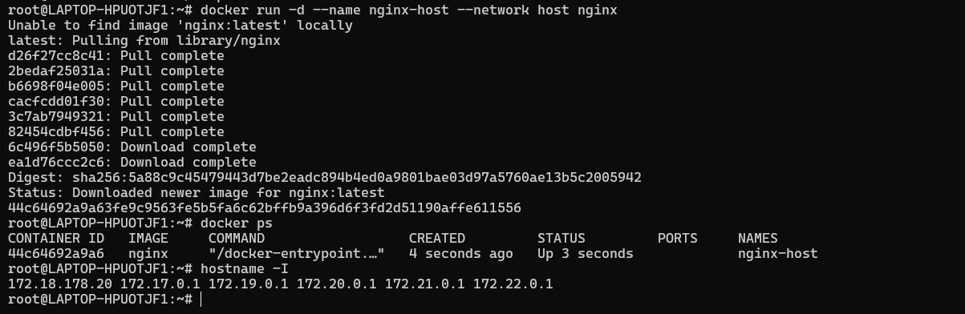
- Check the container's network configuration
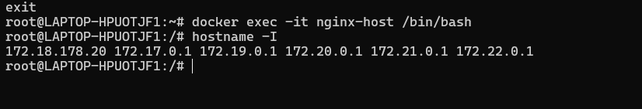

Advantages of Host Networking
- Better Performance
  - No Network Address Translation (NAT) is used.
  - Packets travel directly through the host's network stack, resulting in lower latency and higher throughput.
- No Port Mapping Required
  - You don't need to use the -p or --publish option.
  - Applications running in the container are directly accessible through the host's network.
- Direct Access to Host Network
  - The container can use the host's network interfaces and IP address.
  - Useful for applications that need direct access to the network.
- Suitable for High-Performance Applications
  - Commonly used for network monitoring tools, proxies, load balancers, and applications where network performance is critical.
Disadvantages of Host Networking
- No Network Isolation
  - The container shares the host's network namespace.
  - It does not have its own separate IP address.
- Port Conflicts
  - If the host is already using a port (for example, port 80), another container using host networking cannot use the same port.
  - Only one application can bind to a given port on the host.
- Reduced Security
  - Since the container shares the host's network, it has greater access to the host's networking resources.
  - This increases the potential impact if the container is compromised.
- Less Flexible
  - Host networking is not ideal when running multiple instances of the same application on the same machine because they cannot listen on the same ports.

- Named volume: Launch a containerized database (e.g., MySQL or PostgreSQL) using a named volume to store its data. Stop and remove the container, then recreate it using the same named volume. Verify that the data persists across container recreations.
-Launch a containerized database using named volume to store its data
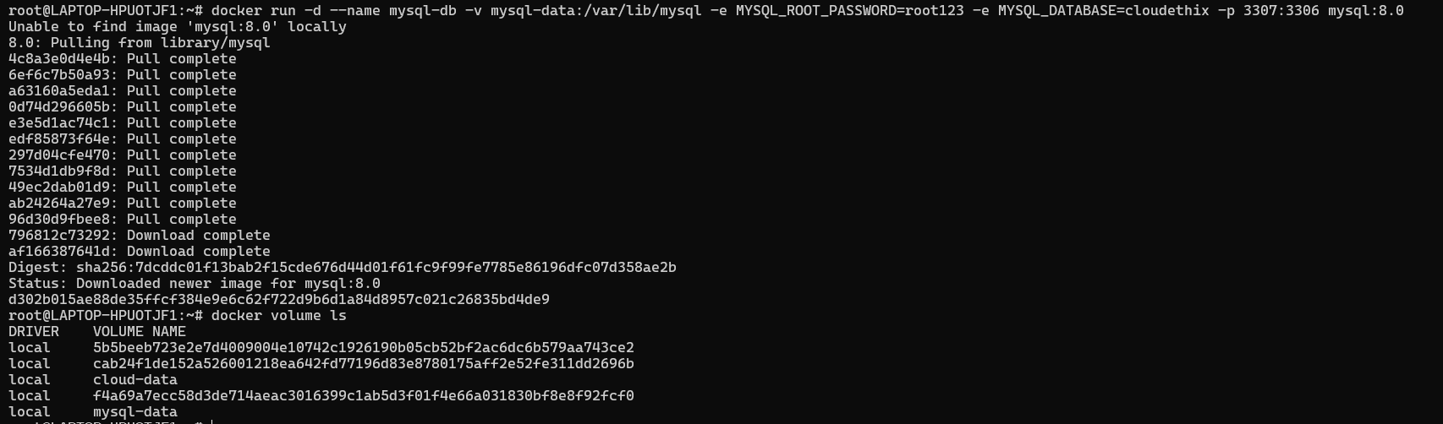
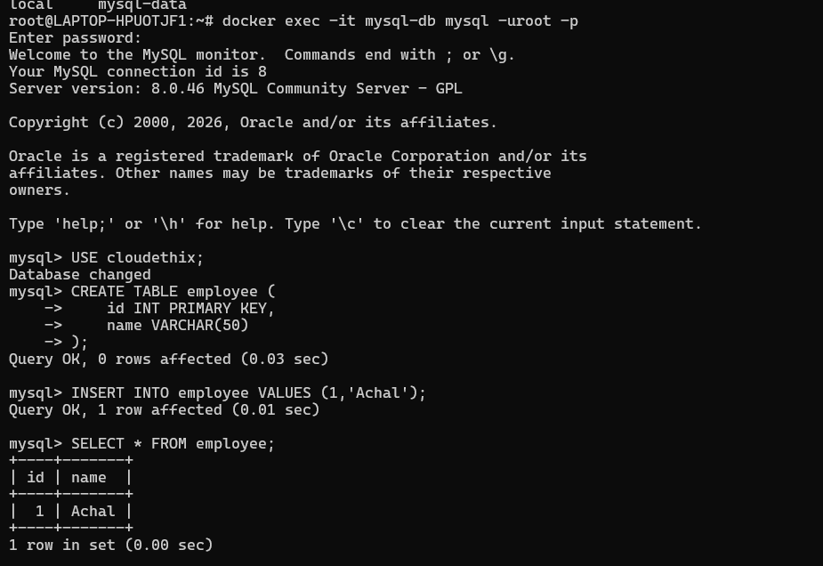
-stop and remove the container
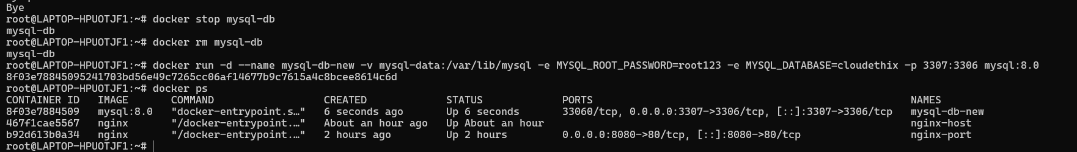
-recreate it using a same name volume
- Verify that the data persists across container recreations.
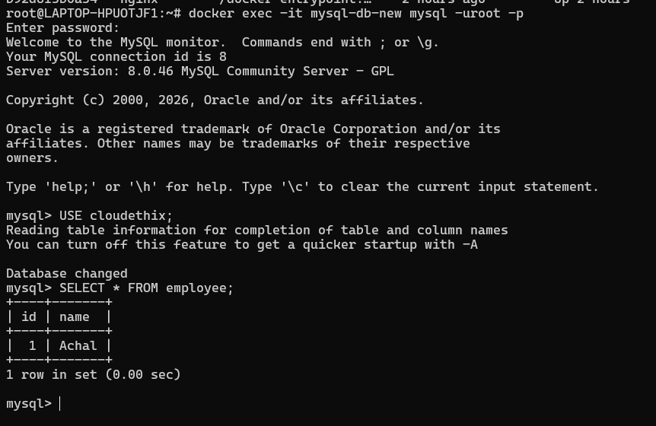
- Bind mount: Create a simple web application with a local directory containing HTML, CSS, and JavaScript files. Run a web server container (e.g., NGINX or Apache) and bind mount the local directory to the container's webroot. Verify that the web application is accessible and update the local files to see if changes are reflected in the container.
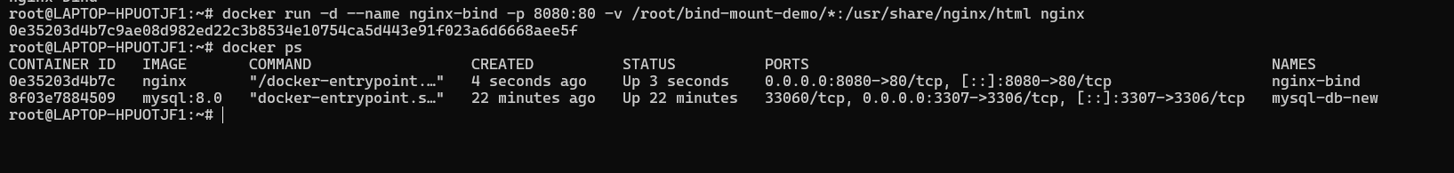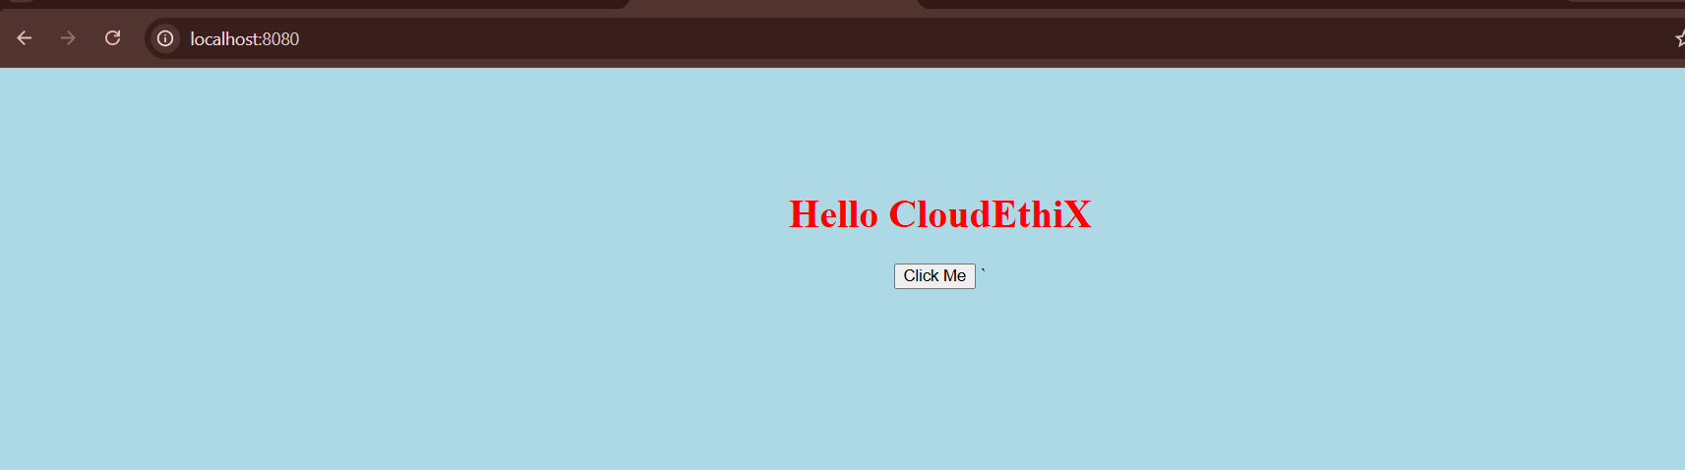
-update index.html file local file
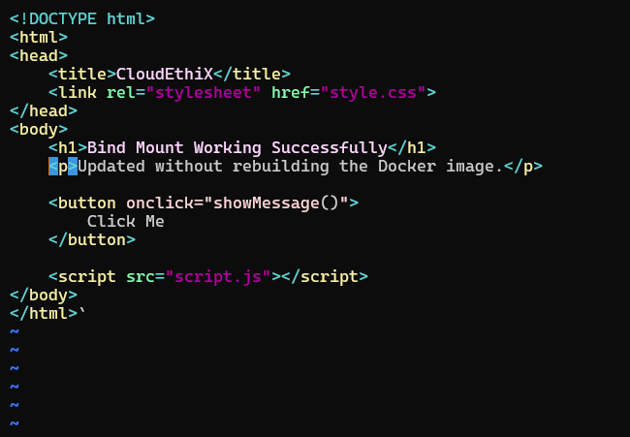
- Verify that the web application is accessible and update the local files to see if changes are reflected in the container.
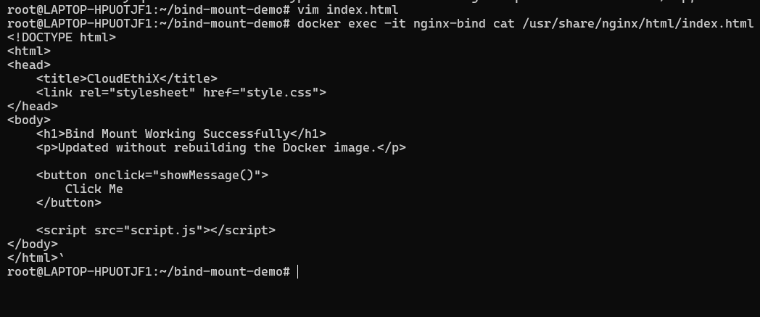
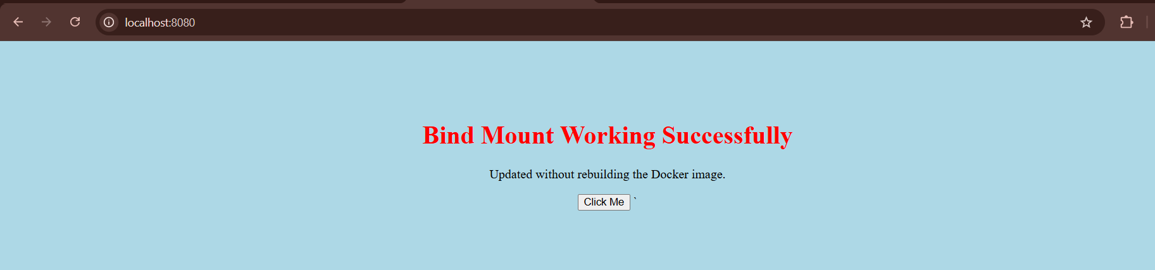
- Volume backups: Using a container with a named volume, create a backup of the volume's data by either exporting it as a tarball or copying the data to a host directory. Restore the data to a new container and verify that the restoration was successful.
-Create a container using a name volume
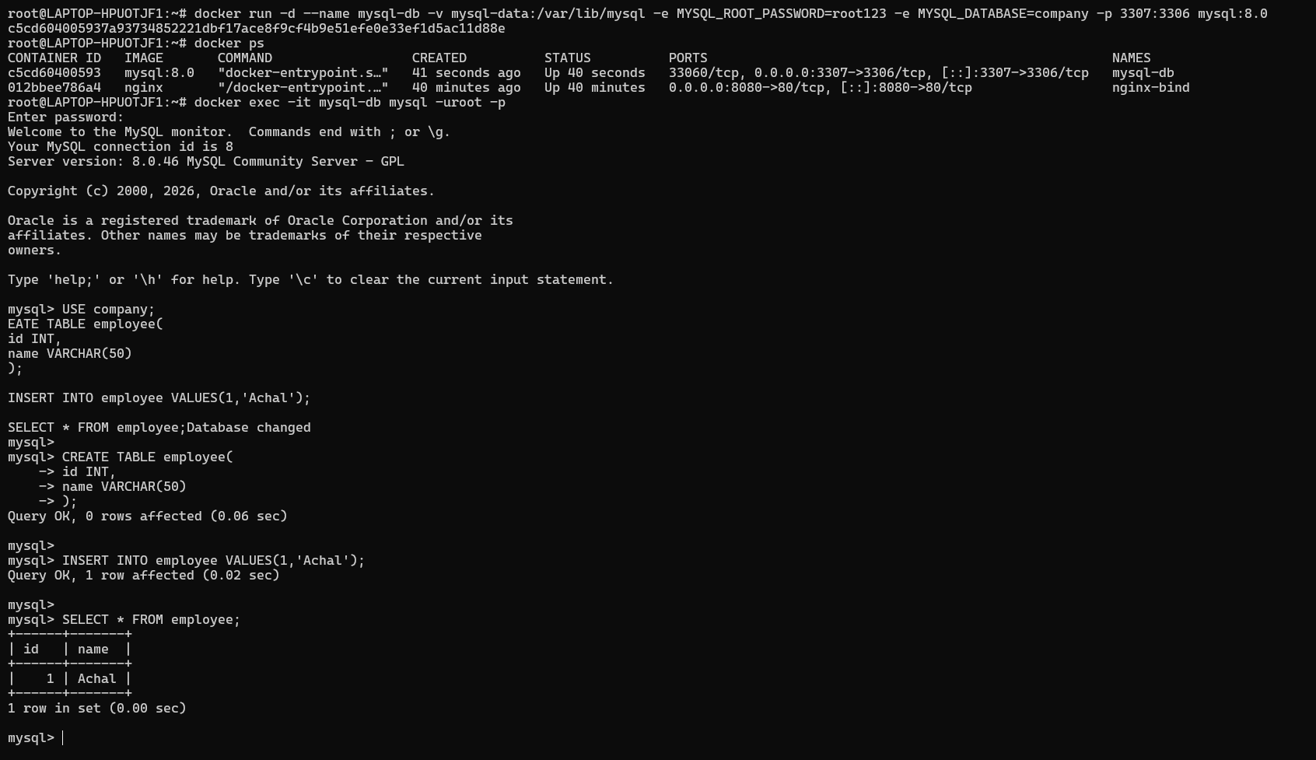

-Create a backup dirrectory
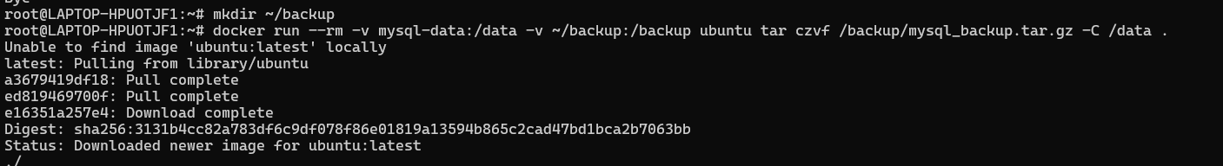
-copying the data into host dirrectory
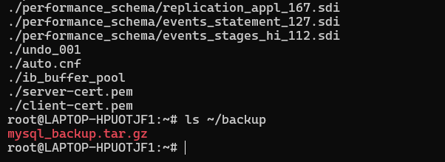
- Restore the data to a new container and verify that the restoration was successful.
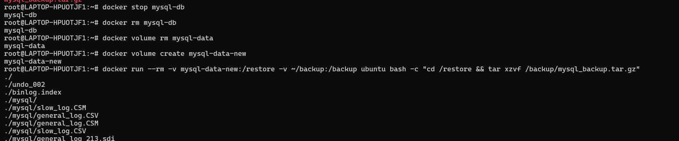
- Start MySQL using the restored volume
- Verify the restore
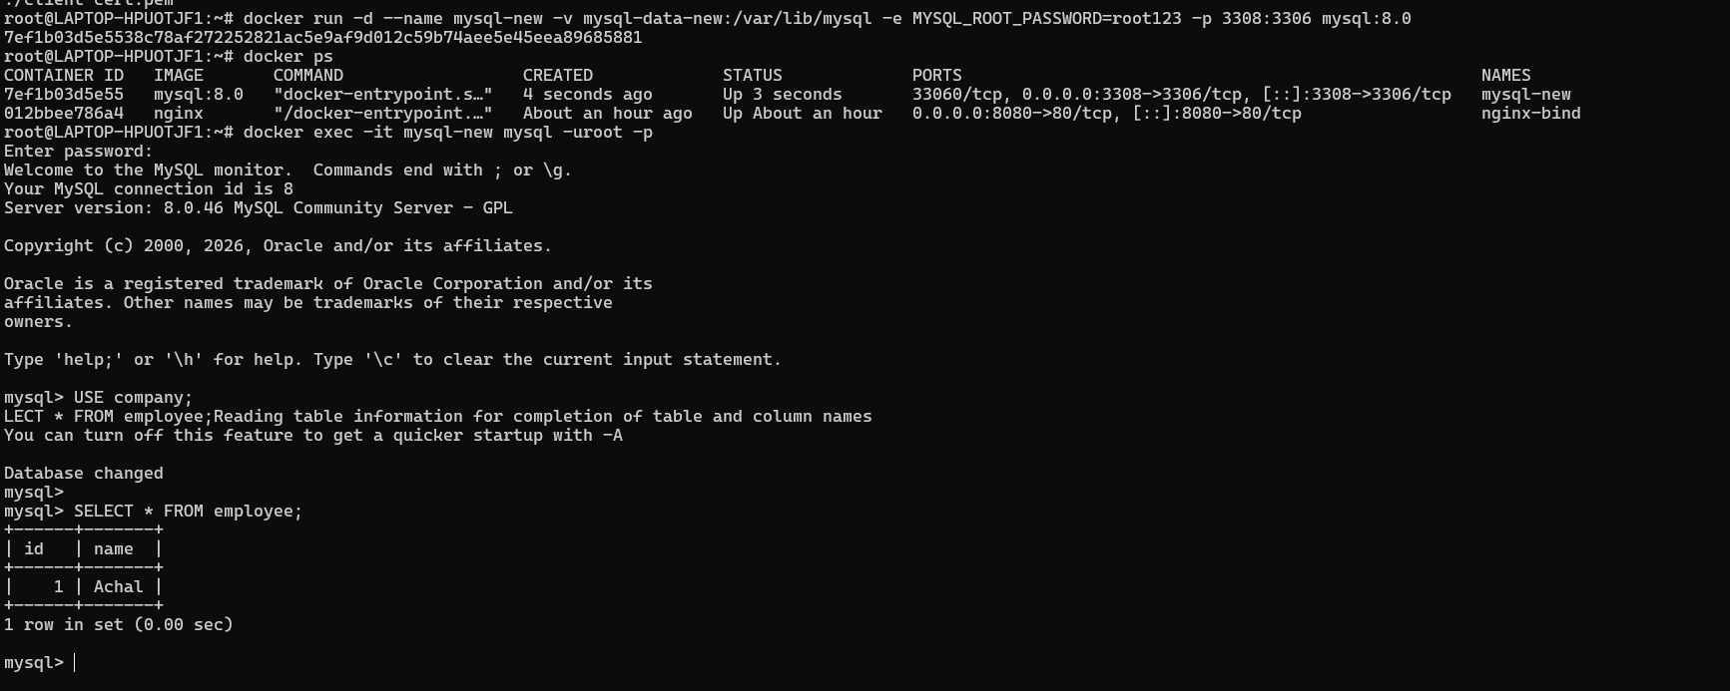
- Docker Compose networking: Create a Docker Compose file that defines a multi-container application with a frontend, backend, and database. Set up custom networks and volumes for the services and ensure that they can communicate with each other and store data persistently

-Create a Docker Compose file that defines a multi-container application with a frontend, backend, and database.
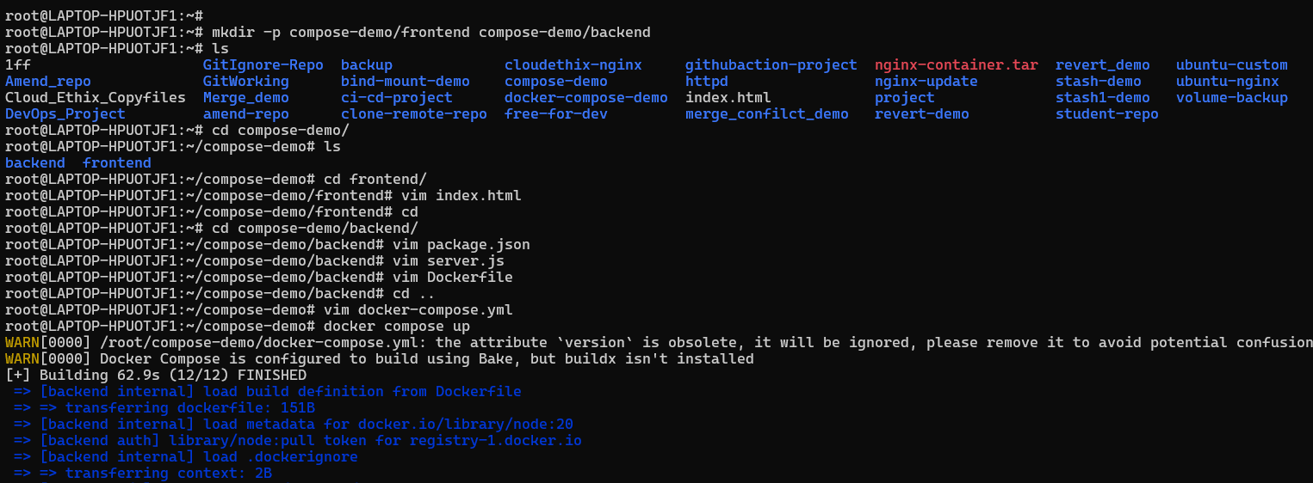
-docker-compose file
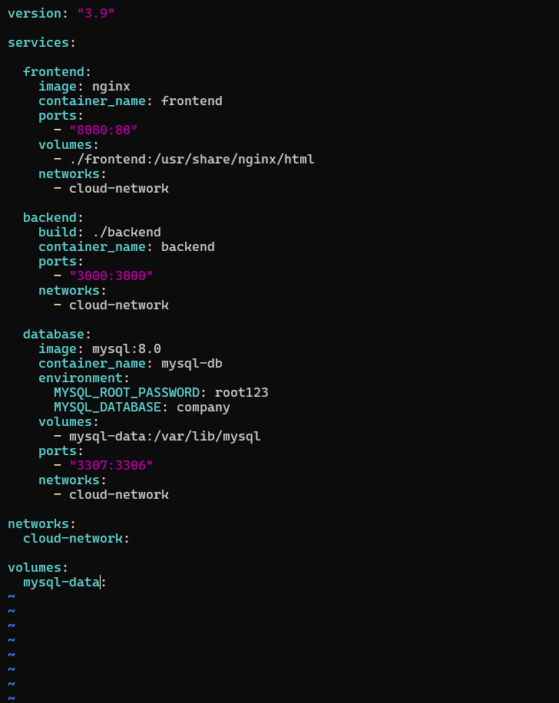
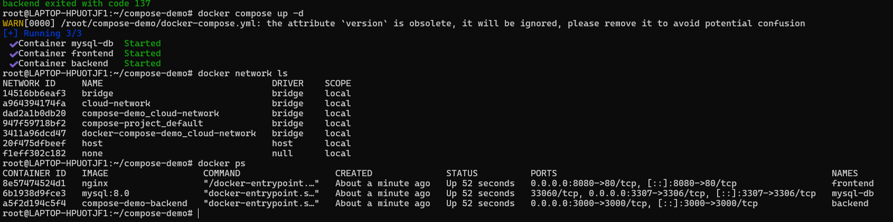
- ensure that they can communicate with each other and store data persistently
